13-5 The Cosine Function Name ______________________

Learning Targets -

Use your calculator to fill in the table below. Then graph the set of ordered pairs using the angle measure as ***x*** and the sine as ***y***.

|  |  |  |  |  |  |  |  |  |  |
| --- | --- | --- | --- | --- | --- | --- | --- | --- | --- |
| angle | 0 | 30 | 45 | 60 | 90 | 120 | 135 | 150 | 180 |
| cos |  |  |  |  |  |  |  |  |  |

The Cosine Curve

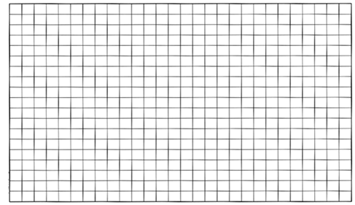

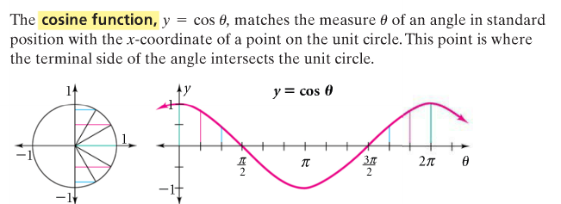

Use your calculator to find cos 210, cos 240, cos 270, cos 300, cos 330, and cos 360.

**\*\*Notice how this graph matches the one in degrees.\*\***

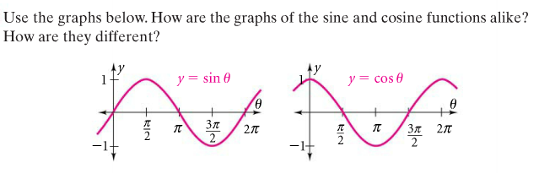

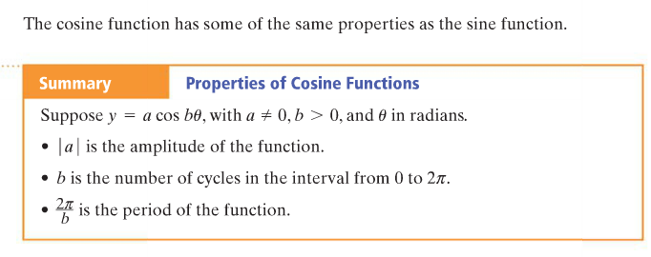 

**\*\*The curve will change for variations in a, the amplitude, and b, the number of cycles.\*\***

**Example 2 - Sketching the Graph of a Cosine Function.**

**Sketch the graph of y = 1.5 cos 2θ.**

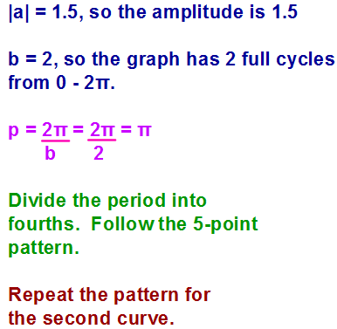



Sketch the graph of -2 cos πθ. Use the same steps as in Example 2.

**Writing the Equation for a Cosine Function**

Write an equation for each cosine function below.

1) 2)

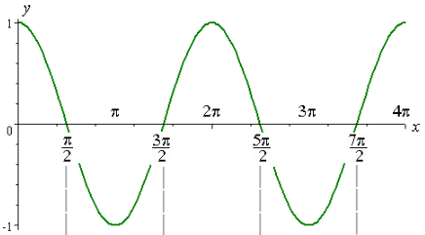 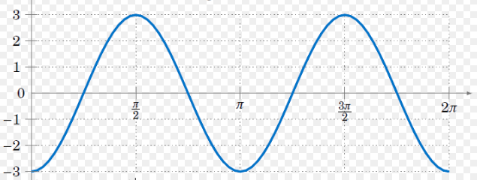

a = ____ b = ____ a = ____ b = ____

Equation: _____________ Equation: _____________

3) 4)

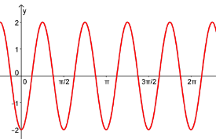 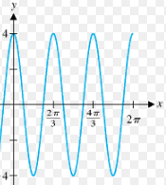

a = ____ b = ____ a = ____ b = ____

Equation: ___________ Equation: ____________