13-4 The Sine Function

Learning Target 1 -

Use your calculator to fill in the table below. Then graph the set of ordered pairs using the angle measure as ***x*** and the sine as ***y***. 

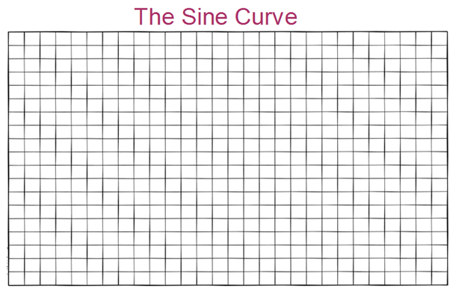

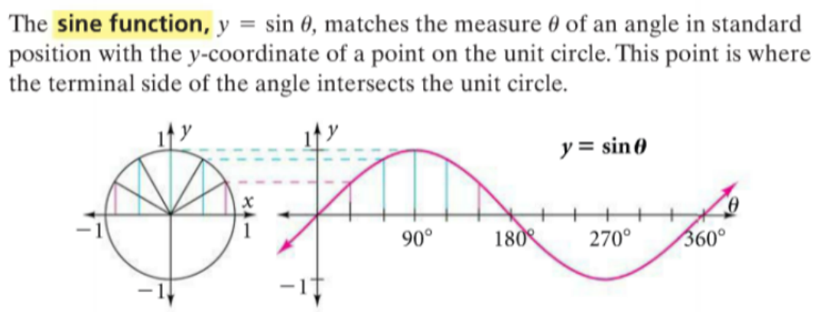

Use your calculator to find sin 210, sin 240, sin 270, sin 300, sin 330, and sin 360.

As you've seen, angle measures can be expressed in degrees of in radians. In this section, when no unit is mentioned, use ***radians***.

You can graph the sine function in radians. In the unit circle, you can show radian measures along the circle as lengths of arcs. The points for 1, 2, and 3 radians are marked on the unit circle and on the θ-axis.

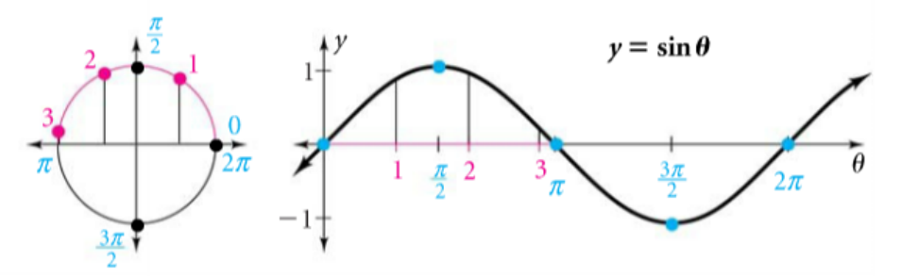

**\*\*Notice how this graph matches the one in degrees.\*\***

Learning Target 2 -

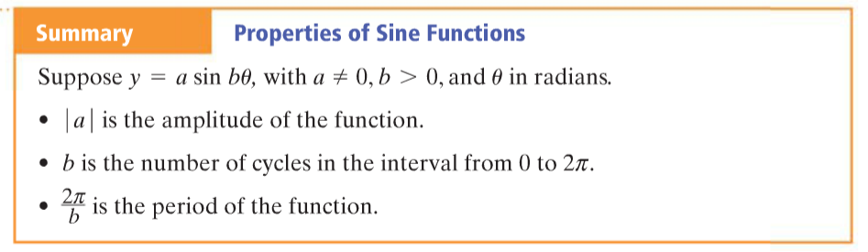

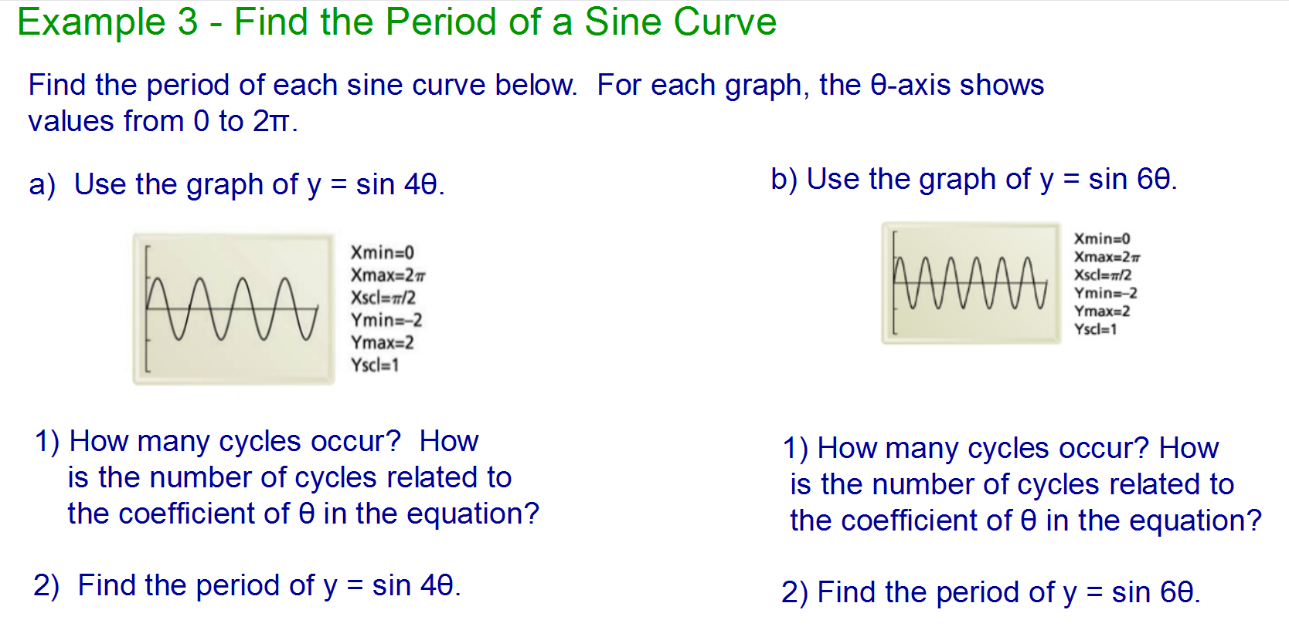

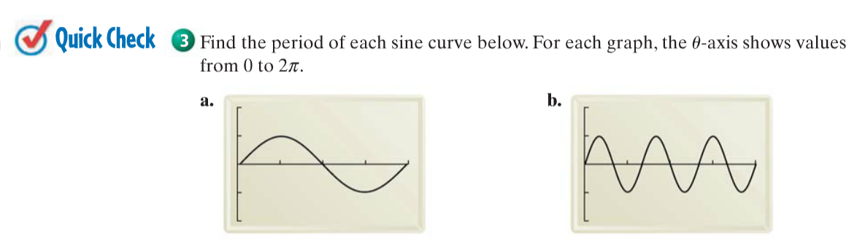

Below is the graph of y = sin θ.

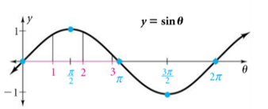

**Example 4 – Find the amplitude of a sine curve. Compare each graph below to the graph above.**

