**Notes 13.1 - Exploring Periodic Data** Name:

Learning Target 1 -

**periodic function -**

**cycle -**

**period -**

**Example 1 – Identifying cycles and periods.**

**AnaIyze the periodic function below. Identify one cycle in two different ways. Then determine the period of the function.**

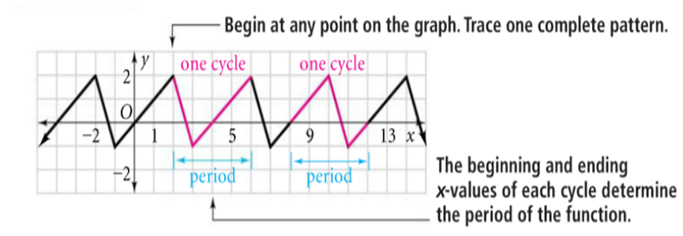

**cycle: _______ ______ period: _____**

 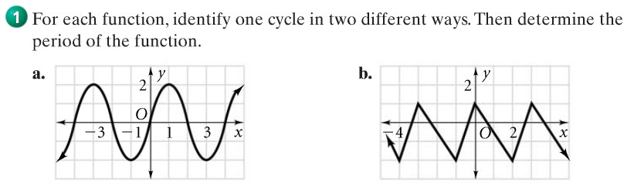

**cycle: ______ _______ cycle: ______ _______**

**period: ________ period: ________**

**Learning Target 2 -**

**Example 2 - Identifying Periodic Functions**

**Determine whether each function *is or is not periodic*. If it is, find the period.**

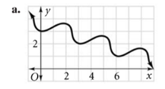 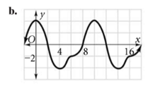 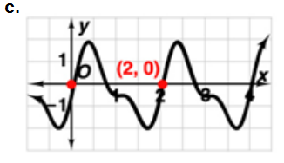

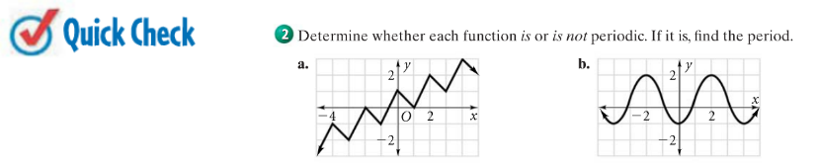

**Notes 13-1 continued**

**Learning Target 3 -**

**amplitude of a periodic function -**

**Amplitude =**

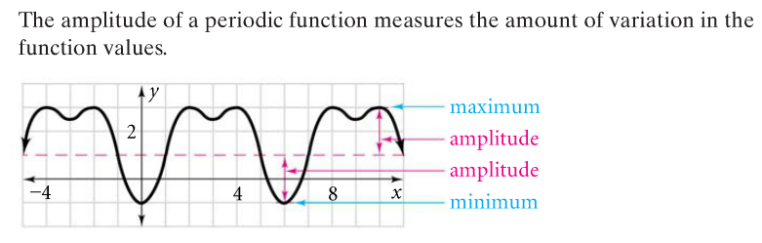

**axis of a periodic function -**

**Axis =**

**Example 3 – Finding Amplitude of a Periodic Function**

**Find the amplitude and the axis of the periodic function below.**

