Hold Up Your Answers Review – 13.1-13.6

1. Find the exact value of the cosine, sine and tangent of 135° .

2. Find the exact value of the cosine, sine and tangent of -120 .

3. Find the exact value of the cosine, sine and tangent of 180 .

4. Given cos θ = -1/2 and tan θ is positive. Find the other two ratios. Then verify the identity.

5. Given sin θ = -12/13 and tan θ is positive. Find the other two ratios. Then verify the identity.

6. Graph one cycle of y = sin 1/2 θ.

7. Graph one cycle of y = -cos θ.

8. Write the equation for the function below. 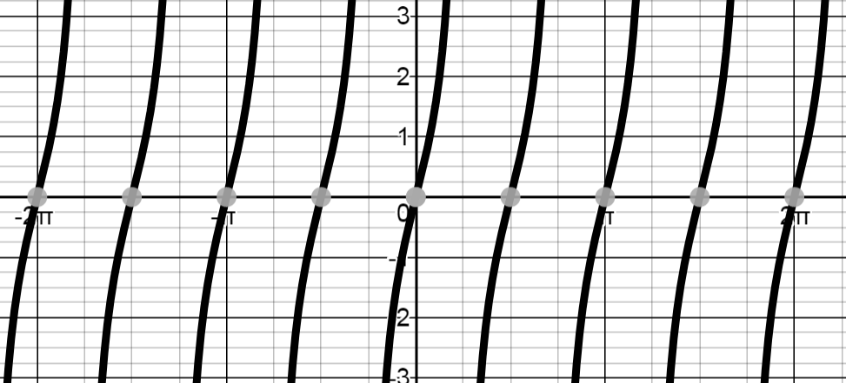

9. Given tan θ = 3/4. What are all possiblevalues of sin θ and cos θ?