Honors Algebra 2 Name _________________________

13.4-13.5 Review

Write a sine equation for each graph.

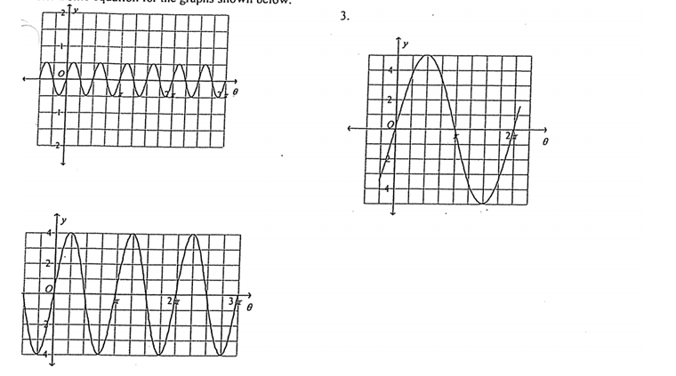

4) A particular sound wave can be graphed using the function **y = 5 sin 4x**. Find the amplitude and

the period of the function.

5) Sketch one cycle of **y = 2 sin 3θ**. 6) Sketch one cycle of **y = 4 cos ½θ**

**Write a sine equation for each of the following:**

7) amplitude = 8, period = 3π 8) amplitude = 4, period = π/3

**Write a cosine equation for each of the following:**

9) amplitude = 5, period = 4 10) amplitude = 1, period = 2π/3