**Writing a Sine or Cosine Equation** Name:

**Write a sine equation for each.**

1) amplitude = 3, period = 2 $π$ 2) amplitude = 2, period = 3

**Write a cosine equation for each.**

3) amplitude = 2, period = $\frac{π}{2}$ 4) amplitude = 1, period = $π$

**Write an equation for each given sine graph.**

5. 6.

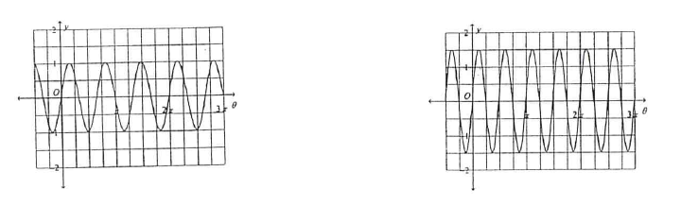

7. 8.

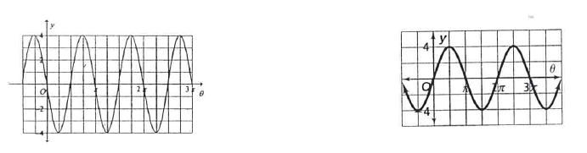

**Write a cosine equation for each given graph.**

9. 10.

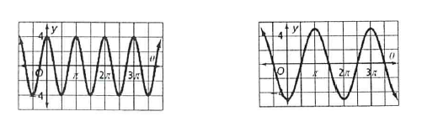

**Sine or cosine? Explain how you know. Write an equation for each.**

11. 12.

