**Practice – Tangent Function Name ______________________________**

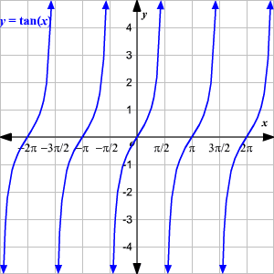

**Sketch** **the** **graph** **of** **each** **function from -2π to 2π .**

**11.** *y* = 2 tan *θ* **6.** *y* = −4 tan * θ*

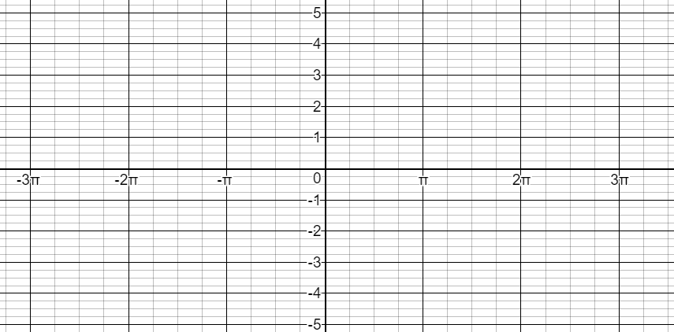 

**12.** *y* = −tan *θ* **15.** *y* = 3 tan 2*θ*

 

**Write an equation for** **each** **tangent** **function.**

**28. 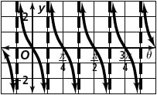 29. 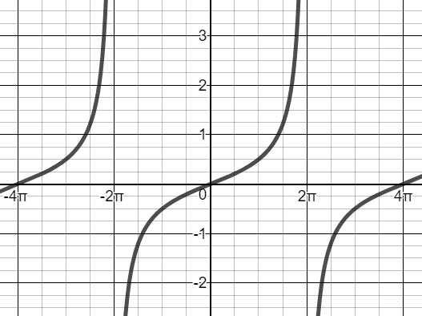 30.** 