Practice 2 - Statistics Name______________________________________

1. Ten members of a high school girls’ basketball team were asked how many hours they studied in a typical week. Their responses (in hours) were $20$, $13$, $10$, $6$, $13$, $10$, $13$, $11$, $11$, $10$.
   1. Using the axis given below, draw a dot plot of these values. (Remember, when there are repeated values, stack the dots with one above the other.)

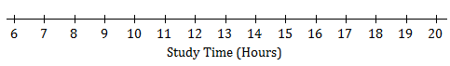

* 1. Calculate the mean study time for these students.
  2. Calculate the deviations from the mean for these study times, and write your answers in the appropriate places in the table below.

|  |  |  |  |  |  |  |  |  |  |  |
| --- | --- | --- | --- | --- | --- | --- | --- | --- | --- | --- |
| Number of Hours Studied | $$20$$ | $$13$$ | $$10$$ | $$6$$ | $$13$$ | $$10$$ | $$13$$ | $$11$$ | $$11$$ | $$10$$ |
| Deviation from the Mean |  |  |  |  |  |  |  |  |  |  |

* 1. The study times for fourteen girls from the soccer team at the same school as the one above are shown in the dot plot below.

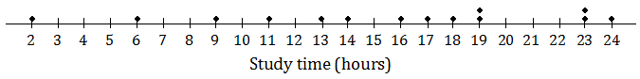

Based on the data, would the deviations from the mean (ignoring the sign of the deviations) be greater or less for the soccer players than for the basketball players? Explain.

1. All the members of a high school softball team were asked how many hours they studied in a typical week. The results are shown in the histogram below.

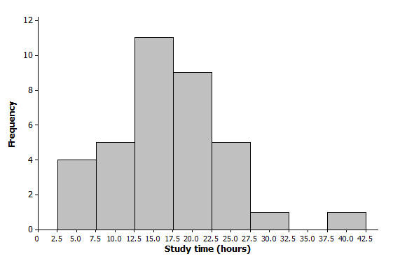

* 1. We can see from the histogram that four students studied around $5$ hours per week. How many students studied around $15$ hours per week?
  2. How many students were there in total? (Add each bar)
  3. Suppose that the four students represented by the histogram bar centered at 5 had all studied exactly 5 hours, the five students represented by the next histogram bar had all studied exactly 10 hours, and so on. If you were to add up the study times for all of the students, what result would you get?
  4. What is the mean study time for these students?
  5. What is the greatest deviation from the mean?
  6. What would you consider a typical deviation from the mean?