Practice 1 - Statistics Name __________________________________

A random sample of eighty viewers of a television show was selected. The dot plot below shows the distribution of the ages (in years) of these eighty viewers.

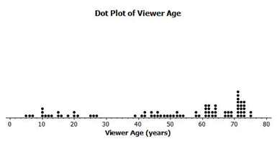

1. What do you think this graph is telling us about the ages of the eighty viewers in this sample?

2. Find the mean, median, and mode of the data.

3. Can you think of a reason why the data presented by this graph provide important information? Who might be interested

in this data distribution.

4. Would you describe this dot plot as representing a symmetric or a skewed data distribution? Explain your answer.

The following histogram represents the age distribution of the population of the United States in 2010.

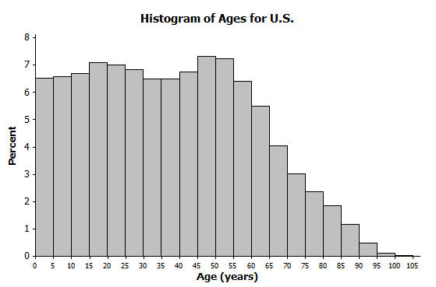

5. What do you think this graph is telling us about the population of the United States?

6. Why might we want to study the data represented by this graph?

Twenty-two juniors from River City High School participated in a walkathon to raise money for the school band. The following box plot was constructed using the number of miles walked by each of the twenty-two juniors.

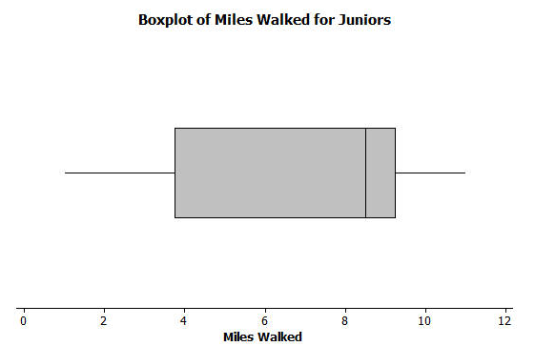

7. What do you think the box plot tells us about the number of miles walked by the twenty-two juniors?

8. Why might understanding the data behind this graph be important?