**Notes 13-6 continued**

Sketch the graph of each function from -2π to 2π.

**1. y = 3 tan θ 2. y = 2 tan 4 θ 3. y = 5 tan π/2 θ**

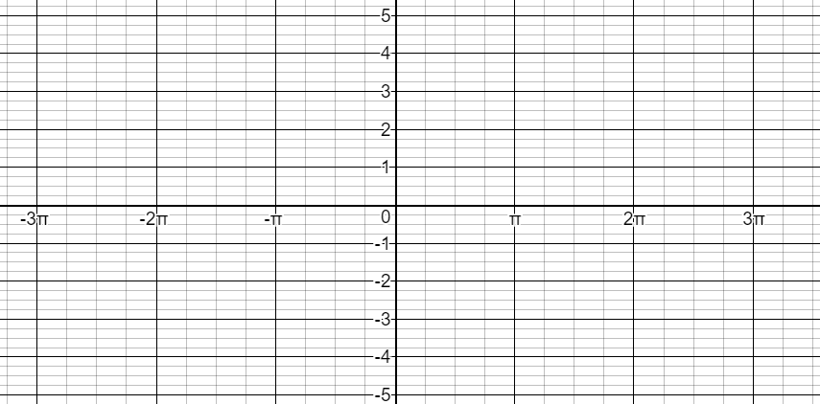  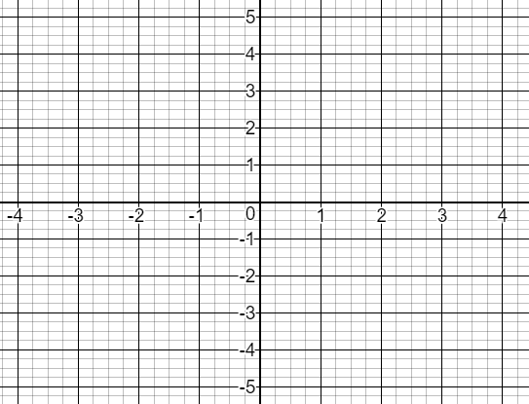

Write an equation for each tangent function below.

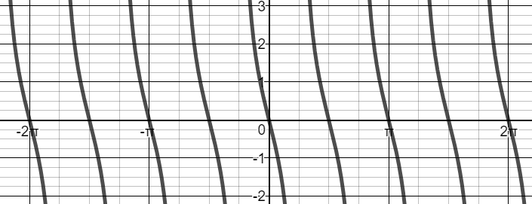 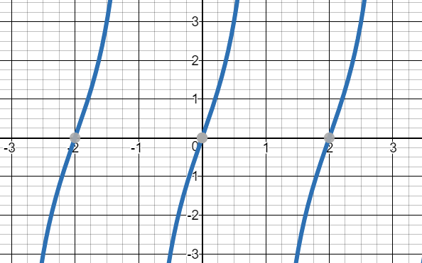

Notes 13-6 continued

**To graph a tangent function**:

- use b to find p, the period

- divide the period by 2 (to determine where the asymptotes are)

- use that number to draw the asymptotes on either side of zero

- space the asymptotes equally throughout the graph

- follow the pattern: asymptote - (-a) - zero - (a) - asymptote

or asymptote - (a) - zero - (-a) - asymptote

**To write an equation for a tangent function:**

- determine the value of a from the graph

* to do this look at the asymptotes (draw them in if they are not there)
* determine the y-value of the graph half way between 0 and one of the asymptotes

- use p, the period, to find b

- write the equation using a and b