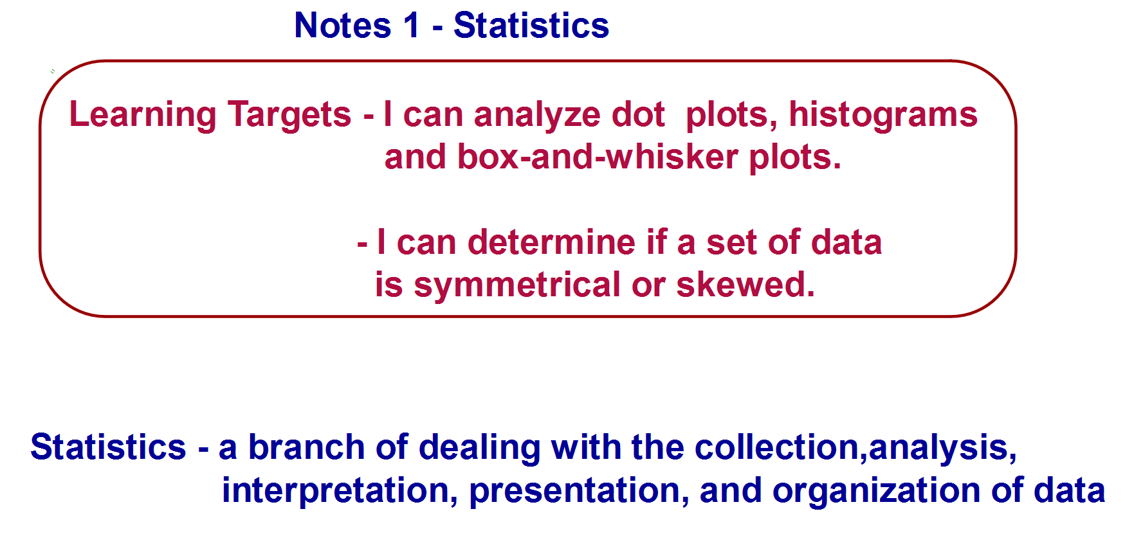

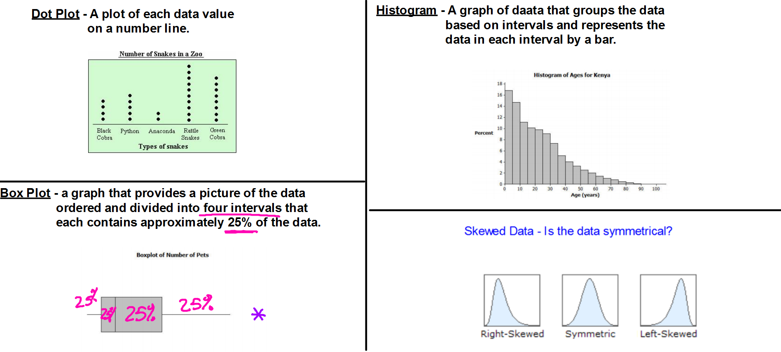

Notes 1 – Statistics

Transportation officials collect data on flight delays (the number of minutes past the scheduled departure time that a flight takes off).

Consider the dot plot of the delay times for sixty Big Air flights during December 2012.

**Dot Plot of December Delay Times**

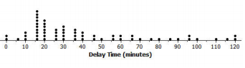

1. What do you think this graph is telling us about the flight delays for these sixty flights?

Find the mean, median, and mode of the data.

2. Can you think of a reason why the data presented by this graph provides important

information? Who might be interested in this data distribution?

3. Would you describe this dot plot as representing a symmetric or a skewed data distribution?

Explain your answer.

The following histogram represents the age distribution of the population of Kenya in 2010.

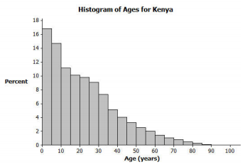

4. What do you think this graph is telling us about the population of Kenya?

5. Why might we want to study the data represented by this graph?

6. Would you describe this histogram as representing a symmetrical or a skewed distribution?

Explain your answer.

Thirty students from River City High School were asked how many pets they owned. The following box plot was prepared from their answers.

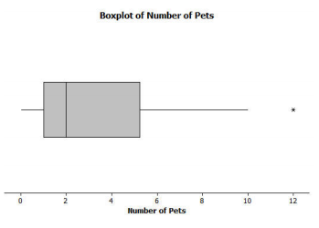

7. What does the box plot tell us about the number of pets owned by the thirty students at

River City High School?

8. Why might understanding the data behind this graph be important?