Honors Algebra 2 Name __________________________

Date _______________ Hour ________

**Special Right Triangles**

**Learning Target 1 – I can use the properties of special right triangles.**

**Part 1 - 45° - 45° - 90° Triangles**

Use the Pythagorean Theorem to find the missing side of each 45° - 45°- 90° triangle below. Write your answers in simplest radical form. (The angles of each triangle are to scale, but the sides are not.)

1. 2. 3.

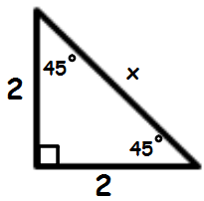 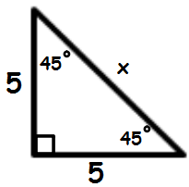 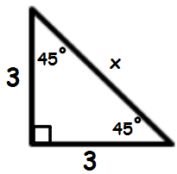

**Show work here:**

1. 2. 3.

What patterns do you notice? What conclusions can you draw?

4. 5. 6.

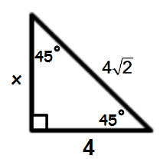 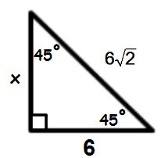 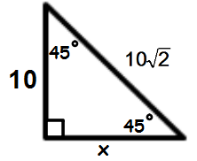

**Show work here:**

4. 5. 6.

What patterns do you notice? What conclusions can you draw?

**Part 2 - 30° - 60° - 90° Triangles**

Use the Pythagorean Theorem to find the missing side of each 30° - 60°- 90° triangle below. Write your answers in simplest radical form. (The angles of each triangle are to scale, but the sides are not.)

1. 2. 3.

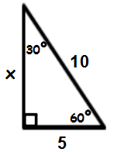 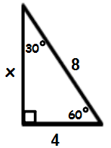 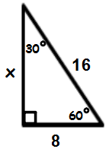

**Show work here:**

1. 2. 3.

What patterns do you notice? What conclusions can you draw?

4. 5. 6.

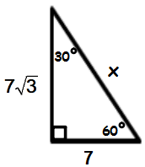 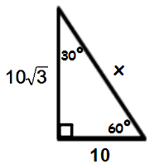 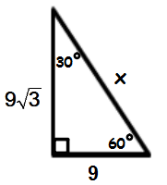

**Show work here:**

4. 5. 6.

What patterns do you notice? What conclusions can you draw?