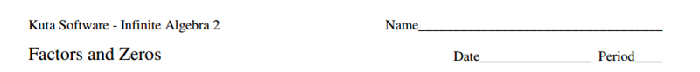

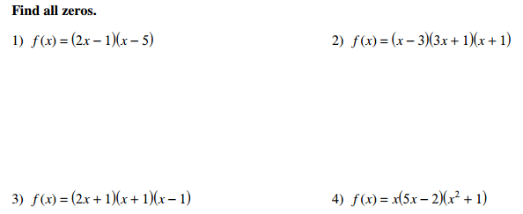

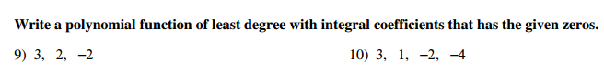



Use the Remainder Theorem to determine if the given polynomial is a factor of the given polynomial.

