Hold Up Your Answers Review 6.1-6.3 Name ___________________

**1) Write the function in factored form.** **y = 2x3 + 10x2 + 12x**

**2) Given the polynomial, find the zeros, state any multiplicities, and sketch the**

**graph. y = (x - 2)2(x + 3)**

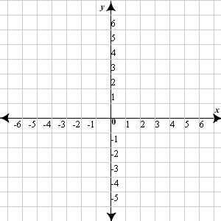

**3) Given the polynomial, find the zeros, state any multiplicities, and sketch the**

**graph. y = (x + 1)(x - 3)3**



**4) Write a polynomial function in standardform with zeros: -3, 0, 0, 4**

**5) Divide using long division. Write your** **answer in fraction form.**

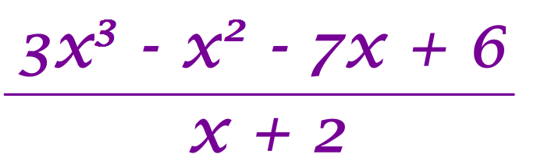

**6) Divide using long division. Write your** **answer in fraction form.**

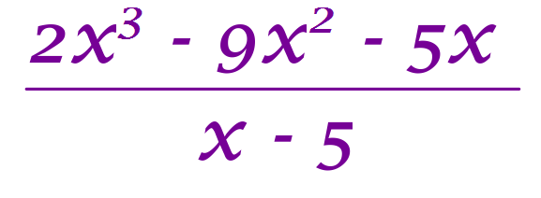

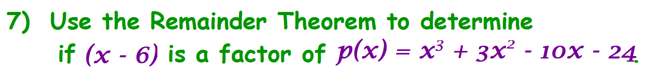

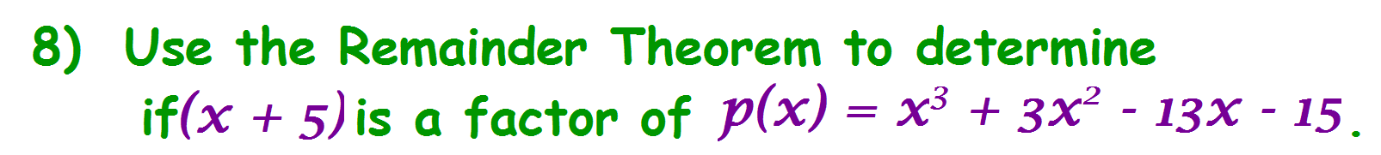

**9) Given the polynomial, find the zeros, state any multiplicities, and sketch the**

**graph.**



**10) Find the relative maximum, relative** **minimum, and zeros of the function.**

**f(x) = x3 - 6x2 - 16x**

11. You want to make a cardboard box. You take an 11-foot by 8-foot piece of cardboard

and cut an x-foot by x-foot square out of each corner. Then you fold it up to make

the box. (Draw a picture!)

1. Write an expression to represent the volume of the box.
2. Find the maximum volume of the box.

c) Find the height, x for that volume.