Honors Algebra 2 Name _________________________

Review – 6.1-6.2 Date _________________ Hour ____

**\*\*Non Calculator Part\*\***

1) Determine if the end behavior describes a positive odd polynomial, a negative odd polynomial, a positive

even polynomial, or a negative even polynomial.

   

__________ ____________ ___________ ____________

2) Write each polynomial in **standard form** **and** **classify** the polynomial according to its degree and number of

terms.

a)  b) 

3) Write the given polynomial in standard form. **y = (x – 4)(x + 1)(x – 2)**

4) Write each polynomial in factored form.

a)  b) 

5) Based on the end behavior, match each function with its graph. Explain.

 



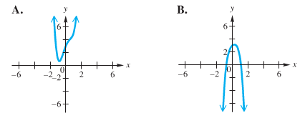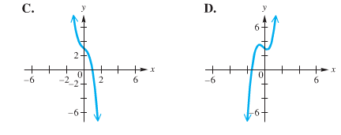

6) For each polynomial find and label the zeros and sketch its graph.

a) **f(x) = (x +2)(x – 4)(x +6)** b) **y = x² + 3x - 10**

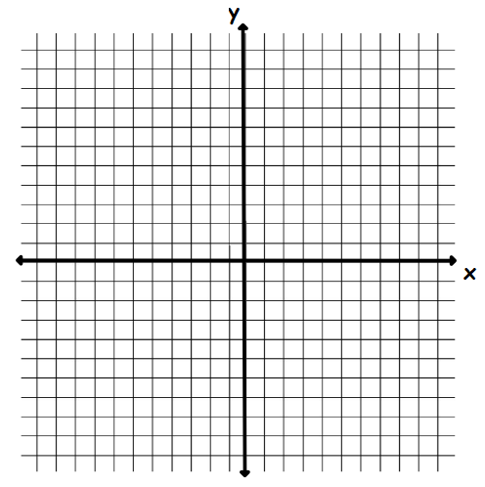 

7) Write a polynomial function in standard form with the given zeros.

a) -5, 3, 2 b) -2, 0, 0, 4

8) For each function, determine the zeros. State the multiplicity of any multiple zeros.

a) **y = (x + 4)(x – 5)²** b) 

**Calculator Part**

10) Find the relative minimum, relative maximum, and zeros of **f(x) = x³ - x² -12x.**

11) You want to make an open box from the material below. Write a function for the height,

width, and length of the box. Use a calculator to graph your equation and find the maximum

volume of the box. What are the height, width and length of the box that will yield the

maximum volume?

