Honors Algebra 2 Name Answer Key

Review – 6.1-6.2 Date _________________ Hour ____

**\*\*Non Calculator Part\*\***

1) Determine if the end behavior describes a positive odd polynomial, a negative odd polynomial, a positive

even polynomial, or a negative even polynomial.

   



2) Write each polynomial in **standard form** **and** **classify** the polynomial according to its degree and number of

terms.

a)  b) 

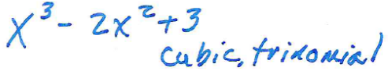 **-x2 - 3x; quadratic, binomial**

3) Write the given polynomial in standard form. **y = (x – 4)(x + 1)(x – 2)**

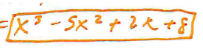

4) Write each polynomial in factored form.

a)  b) 

 

5) Based on the end behavior, match each function with its graph. Explain.

 **D**  **C**

**A** **B**

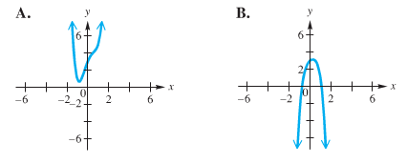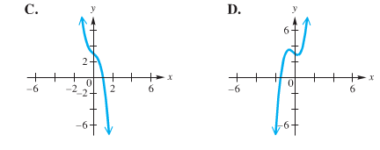

6) For each polynomial find and label the zeros and sketch its graph.

a) **f(x) = (x +2)(x – 4)(x +6)** b) **y = x² + 3x - 10**

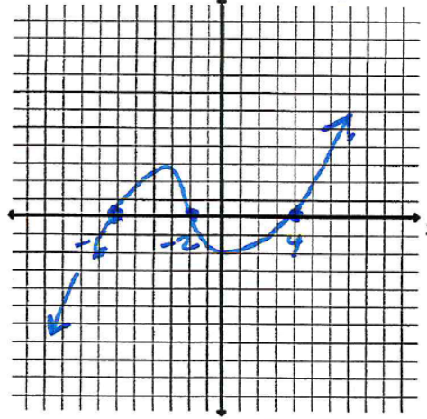 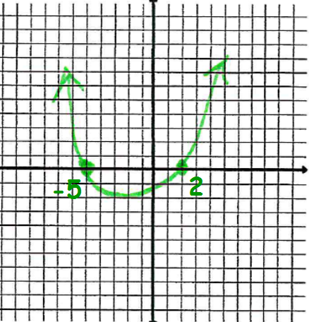

7) Write a polynomial function in standard form with the given zeros.

a) -5, 3, 2 b) -2, 0, 0, 4

 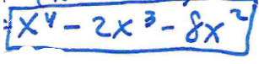

8) For each function, determine the zeros. State the multiplicity of any multiple zeros.

a) **y = (x + 4)(x – 5)²** b) 

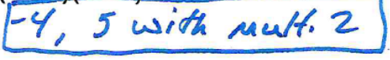 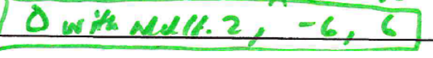

**Calculator Part**

10) Find the relative minimum, relative maximum, and zeros of **f(x) = x³ - x² -12x.**

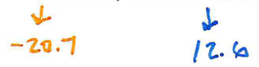 

11) You want to make an open box from the material below. Write a function for the height,

width, and length of the box. Use a calculator to graph your equation and find the maximum

volume of the box. What are the height, width and length of the box that will yield the

maximum volume?

