Algebra 2

**2016**

**Final Exam Study Guide**

**NC = No calculator**

Show your work on separate sheets of paper. You may need graph paper.

**UNIT 1: SYSTEMS OF EQUATIONS**

1. **NC** Solve the following system of equations: $\left\{\begin{aligned}y=-\frac{5}{3}x+3 \\ y=\frac{1}{3}x-3\end{aligned}\right.$
2. What method (elimination, substitution, or graphing) would be best to solve this system? Why?
3. Solve the system by graphing. 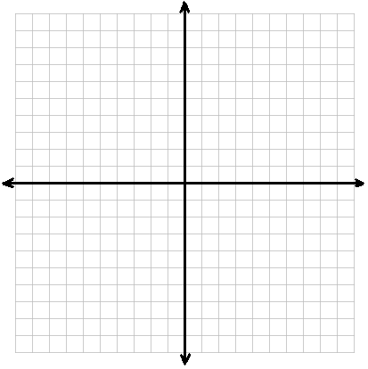
4. Check your solution.
5. **NC** Solve the following system of equations: $\left\{\begin{aligned}y=6x-11 \\ -2x-3y=-7\end{aligned}\right.$
6. Which method would be the best to use for this system? Why?
7. Solve the system by **substitution**.
8. **NC** Solve the following system of equations: $\left\{\begin{aligned}5x+y=9 \\ 10x-7y=-18\end{aligned}\right.$
9. Which method would be the best to use for this system? Why?
10. Solve by **elimination**.
11. **NC** Solve the following systems of equations using the method of your choice.
$\left\{\begin{aligned}y=5x-7 \\ -3x-2y=-12\end{aligned}\right.$

$\left\{\begin{aligned}-4x+9y=9 \\ x-3y=-6\end{aligned}\right.$

$\left\{\begin{aligned}y=\frac{1}{3}x-3 \\ y=-x+1\end{aligned}\right.$

12. **NC** Graph the following system of inequalities. Then, circle the points below that are solutions to the system.

$$y<-3x-4$$

$y≥\frac{1}{2}x+3$

Circle the solutions to the system:

(0, 0) (-4, 3) (-7, 1)

(5, 3) (-2, -3) (-3, -1)

1. **NC** Maria is hosting a party. She places an order at Pizza Hut for 5 pizzas and 4 breadsticks for a total of $51. Halfway through the party, she realizes that she will need one more pizza and 2 more order of breadsticks. This time she was given a total of $15. How much does a pizza cost? How much does a breadstick cost?
2. **NC** Saleh has to buy apples and bananas. A bunch of bananas is $0.30 and an apple is $0.50. He spends a total of $7.00 . He bought 3 times as many bananas as he did apples. How many apples did he buy? How many bananas did he buy?

**UNIT 2: FAMILIES OF FUNCTIONS**

1. NC Given the family name, find the parent equation and graph it. Determine the domain, range, and end behavior.

|  |  |
| --- | --- |
| Family: Quadratic  Equation: ______________    Domain:  Range:  End behavior: | Family: Radical  Equation: ______________    Domain:  Range:  End behavior: |
| Family: Absolute Value  Equation: ______________    Domain:  Range:  End behavior: | Family: Exponential Growth  Equation: ______________    Domain:  Range:  End behavior: |

1. For the function $a*f\left(x-b\right)+c$, complete the table for the effects of each parameter. Name two examples of values for each situation and describe the effect in words.

|  |  |  |
| --- | --- | --- |
| Examples: (One reflected, one not)  Effect: | $$b≥0$$ Examples:  Effect: | $$c≤0$$ Examples:  Effect: |
| Examples: (One reflected, one not)  Effect: | $$b≤0$$ Examples:  Effect: | $$c≥0$$ Examples:  Effect: |
| $$a<0$$ Examples: Effect: |

1. Graph the following functions. Find their domain and range.

|  |  |
| --- | --- |
| Domain:  Range: | $$f\left(x\right)=\sqrt{x+5}+2$$ Domain:  Range: |
| $$f\left(x\right)={\left(x+2\right)}^{2}-4$$ Domain:  Range: | $$f\left(x\right)=-\sqrt{x}+4$$ Domain:  Range: |

1. For each graph below, determine whether it is a function. Then determine its domain and range in interval notation. Identify **ONE solution to the function (point on the graph)** and **ONE solution to f(x) = 0 (x-intercept).** If asked, write the equation for the graph **(assume no vertical stretch or shrink).**

|  |  |
| --- | --- |
| Function? YES/NO  Domain:  Range:  Increasing:  Decreasing: | Function? YES/NO  Domain:  Range:  Increasing:  Decreasing: |
| Function? YES/NO  Domain:  Range: | Function? YES/NO  Domain:  Range:  Increasing:  Decreasing: |
| Function? YES/NO  Domain:  Range:  Increasing:  Decreasing: | Function? YES/NO  Domain:  Range: |

1. For each graph, draw two lines connecting it to its matching **domain** and **end behavior.**

|  |  |  |
| --- | --- | --- |
| **DOMAIN** |  | **END BEHAVIOR** |
| $$\{x:all real numbers\}$$ |  | As x approaches ∞, y approaches 0.  As x approaches -∞, y approaches ∞. |
| $$\{x:1≤x<∞\}$$ |  | As x approaches 1, y approaches ∞.  As x approaches ∞, y approaches - ∞. |
| $$\{x:all real numbers\}$$ |  | As x approaches -∞, y approaches 1.  As x approaches ∞, y approaches ∞. |

1. The graph of a function is given. Determine whether the function is increasing, decreasing, or constant on the interval (1, 2)

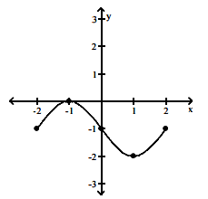

7 ) f(x) =│x│ and g(x) = -4│ x +1 │+ 2. Describe how to transform the graph of f into the graph of g.

**UNIT 3: QUADRATICS**

1. Which form of the quadratic equation shows the minimum or the maximum value of the function without changing the form of the equation
2. Standard form b) factored form c) vertex form
3. NC Which of the following equations shows the minimum or the maximum of h(x)?

h(x) = 2 (x + 3) (x +1) h(x) = 2 (x +2)2 – 2 h(x) = 2x2 + 8x + 6

Does h(x) have a maximum or a minimum?

1. The John Deere Company has found that the revenue from sales of heavy-duty tractors is a function of the unit price  that it charges. The revenue  is



What unit price should be charged to maximize revenue? What is the maximum revenue?

1. The sum of the areas of two square plots of land is 45 square feet. The length of the side of one of the squares is 3 feet more than the length of the side of the other. What is the length of the sides of each square area?
2. NC The graph below can be represented by which of the following equations:

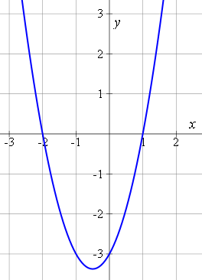

1. y = (x – 2)(x + 1)
2. b) y = (x – 1)(x + 2)
3. c) y = (x + 1)(x + 2)
4. d) y = (x – 1)(x – 2)
5. NC Select **ALL** of the functions that can represent the following graph

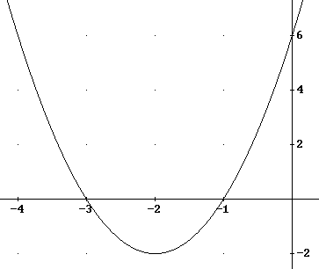

1. 2x2+ 4x +3
2. 2(x + 3)(x + 1)
3. 2(x + 2)2 -2
4. 2(x – 3)(x – 1)
5. 2x2 +8x +6
6. 2(x – 2)2 – 2

1. Simplify each expression. Write your answer in *a + bi* format.
2. −3 + 6i − (−5 − 3i) − 8i
3. (−2 − i)(4 + i)
4. −6(4 − 6i)2
5. (6 – 2i) – (11 + 4i)
6. Solve the following equation using one of the following methods: quadratic formula, factoring, taking square roots, completing the square (don’t forget to try GCF first).
7. (p – 6)2 = 9
8. x 2 − 11x + 19 = −5
9. n 2 + 8n = 3n
10. x 2 + 4x+ 6 = 0
11. 4x2 - 2x = 5
12. 3x2 + 6 = 12
13. How many times does each of the following functions intersect the x-axis?
$y= 3x^{2}+\frac{2}{3}x- \frac{1}{3}$

$f\left(x\right)=\frac{4}{3}x^{2}-4x+3$

14. y = $2x^{2}-\frac{1}{2}x+ \frac{3}{2}$

**UNIT 4: EXPONENTS**

Write in rational exponent form

1.  2. 

Write in radical form.

3. 4. 

Simplify . Your answers should contain only positive expoents.

5. 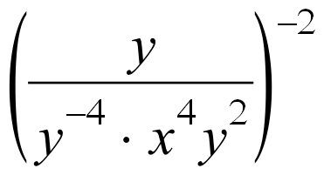 6. 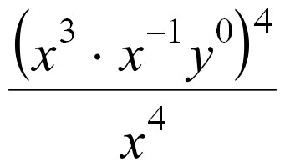

7. 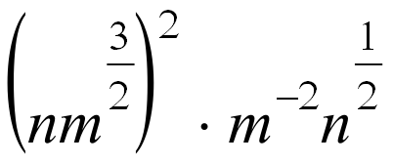 8. 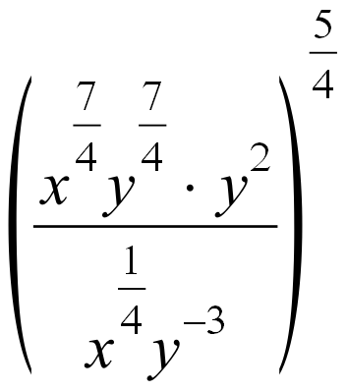

**RADICAL FUNCTIONS**

1. Solve each following radical equation. Determine whether each solution is extraneous.
2. 

$\sqrt{90-x}=x$

$\sqrt{x-5}=\sqrt{10-2x}$

**SLOT: RATIONAL FUNCTIONS**

1. Simplify the following rational expression:



1. Solve the following rational equation, show your steps and indicate any extraneous solutions.

$\frac{4}{x}=\frac{-3}{x+8}$

1. Solve the following rational equation, show your steps and indicate any extraneous solutions.



4. Solve for x.



|  |  |  |  |  |  |  |  |
| --- | --- | --- | --- | --- | --- | --- | --- |
|  |  |  |  |  |  |  |  |

Final Exam Review on Rational Exponents and Radicals

1. Simplify:

a) ${25}^{1/2}$ b) ${343}^{1/3}$ c) $7^{5/{4 .}}{ 7}^{2/3}$

1. Simplify:

a) ${{(x}^{1/2}y}^{5/4})(x{ y}^{1/4}$) b) $x^{\frac{3}{4}}.\sqrt[5]{x^{2}}$

c) $\sqrt{96x^{5}y^{7}z^{2}w}$ d) ${(k^{\frac{2}{x}} )}^{\frac{x}{4}}$

1. Simplify. Your answer should contain only positive exponents with no fractional exponents in the denominator. a) $\frac{a^{-5}b^{8}c^{11}}{a^{2}b^{-7}c^{-9}}$ b) $\frac{a^{\frac{4}{5}}}{b^{\frac{-7}{5}}}$ c) $\frac{a^{7}b^{-5}c^{-9}}{a^{2}b^{-3}c^{5}}$
2. Solve the given equation. v + 3 − 1 = 7

= 60 b) -1 =7

5) Write either in radical form or exponential form.

a) $\sqrt[3]{x^{2}y}$ b) ${2x}^{\frac{2}{3}}y^{\frac{1}{3}}$

1. Solve the following equation. $\sqrt{x-2}=x+2$

Linear Programming

6. Each week you must do a minimum of 15 hours of homework. Participation in sports requires at least 8 hours per week. You have no more than 25 hours per week in total to devote to these activities. Write the constraints If x is number of hours you spend doing homework per week and y represent the numbers of hours you spend for sports activities per week.