Honors Algebra 2 Name _________________________
Review 3.3-3.4 Date ________________ Hour _____

Solve each system of inequalities by graphing.
1. 2. 3.
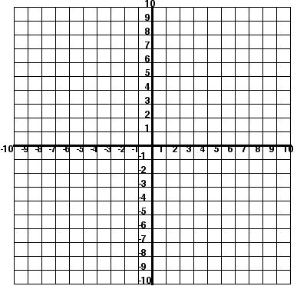

4. Justin bought eight oranges and one grapefruit for a total of $4.60. Later that day, he bought six
oranges and three grapefruits for a total of $4.80. Now he wants to find the price of each. Write and
solve a system of equations to help Justin find the price of each item.

5. The measure of one acute angle of a right triangle is 30° more than twice the measure of the other
acute angle. Find the measure of each angle.

Graph each system of constraints. Name all vertices. Then find the values of x and y that maximize or minimize the objective function.
6. 7. .
Minimum for Maximum for
C = 3x + 4y P = x + 3y
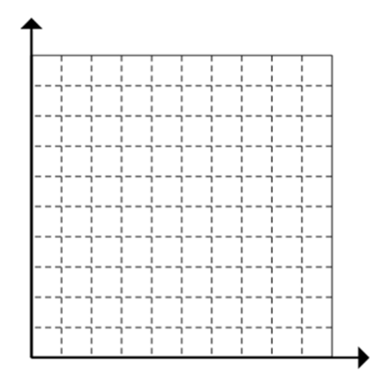

8. Linear Programming
Ben the baker wants to make bread and cake. A loaf of bread is made with 2 cups of flour
and ¼ cup of sugar. Cake is made with 4 cups of flour and 1 cup of sugar. Ben will make a
profit of $1.50 on each loaf of bread and a profit of $4 on each cake. He has 16 cups of flour
and 3 cups of sugar. How many of each should he make to maximize his profit? What is
the maximum profit?

Write and graph the constraints.

