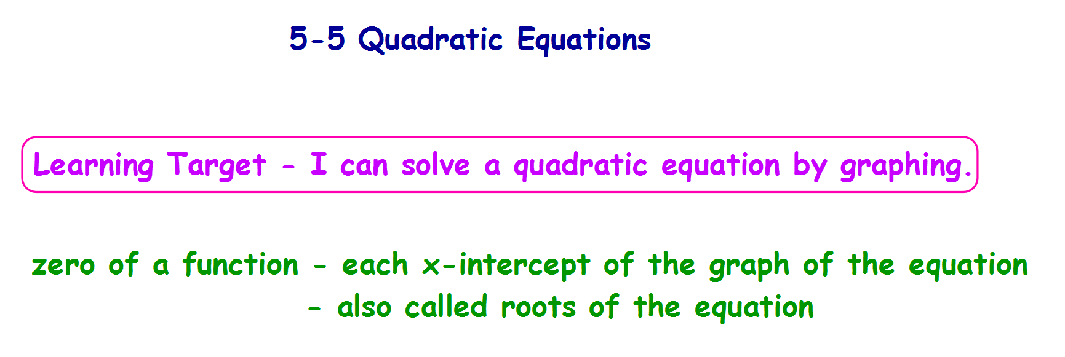**Example 5a - Solve by Graphing**

**Solve x2 - x = 1**

**To find the positive solution on the graphing calculator:**

**1) Graph the function. (Set the equation = to zero if necessary. Change the window**

**values if necessary so you can see the zeros.**

**2) Press [2nd][TRACE] to access the Calculate menu.**

**3) Press [2] to select the zero option.**

**4) Set the Left Bound for the zero you desire to find.To do so, use the**

**left/right keys to place the cursor on the graph a little to the left of the**

**zero, and then press [ENTER].**

**5) Set the Right Bound for the zero. To do so, use the left/right arrow keys**

**place the cursor on the graph a little to the right of the zero, and then press**

**[ENTER].**

**6) Tell the calculator where you guess the zero is located.**



**Example 5b - Real-World Problem Solving - Firefighters**

**A smoke jumper jumps from a plan that is 1600 feet above the ground.**

**The function below gives the jumper's height h in feet at t seconds.**

**h = -16t2 + 1600**

**How long is the jumper in free fall if the parachute opens at**

**1100 feet?**

**Example 5 Real-World Problem Solving**

**Anna throws a ball upward with an initial velocity of 15 ft/sec from a height of 2 ft. Use the equation: h = -16t² + 15t + 2**

**a) How high will it go? Round the answer to the nearest hundredth of a second.**

**b) If no one catches the ball, how long will it be in the air? Round the answer to**

**the nearest hundredth of a second.**

**class work - p. 270-271 #19 (use graphing), 23 - 28, 65**