Family of Functions Worksheet #4 Name _______________________

Functions – Positive and Negative Date ______________ Hour _____

For each function, determine where the function is positive and where it is negative.

1) 2) 3)

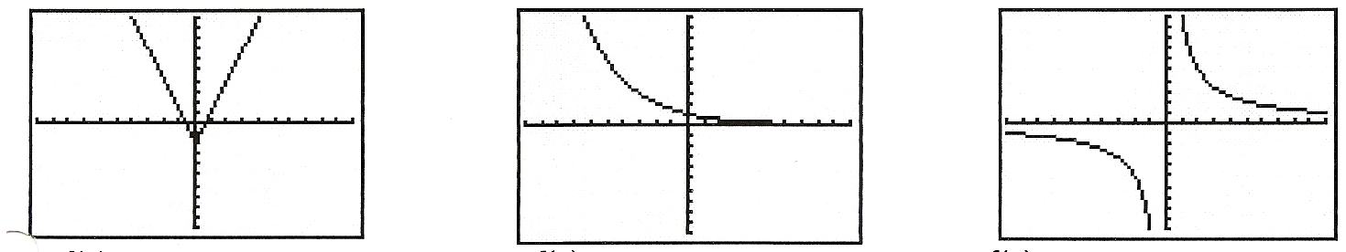

4) 5) 6)

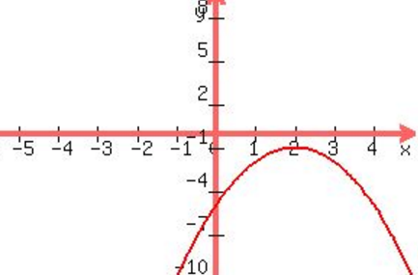 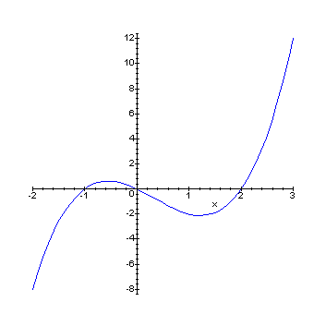 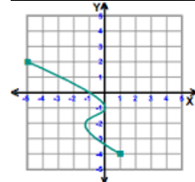

7) 8) 9)

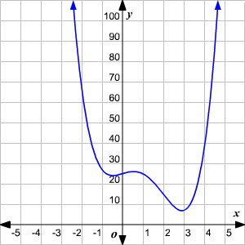 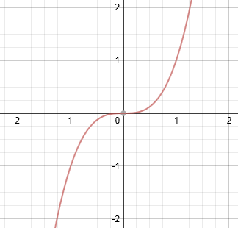 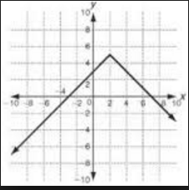

End Behavior of a Function

Determine the end behavior for each function.

