Natural Resources Review Name____________________
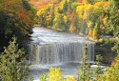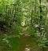
1. These pictures show Michigan’s natural resources. Give at least 1 positive and 1 negative consequence of using each resource.

Positive Uses Negative Uses
Water *Need in order to live *Pollution-trash/chemicals in our water
*Can make electricity from factories

Forests *Outdoor hiking, camping *Cut down too many trees
and exploring. *Causes loss of animal
homes and animal life

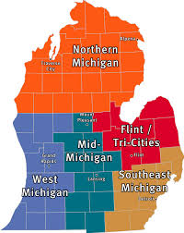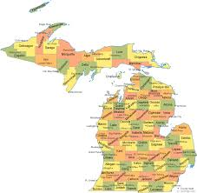
Map 1 Map 2
2.Using the 2 maps explain how Michigan can be divided into regions. Give an example of the regions of each map and why they are divided that way.

Map 1 Larger areas with cities and towns. Divided up by location.

Map 2 Divided into smaller areas called counties. There are 83 counties in Michigan. These smaller areas are able to have for example a local government and to offer road services.

