Final Exam Review – Semester 2 Name___________________________

Hour______

**THIS IS PART OF YOUR FINAL EXAM GRADE!!**

Part 1 - Exponential Functions

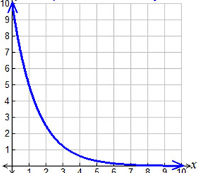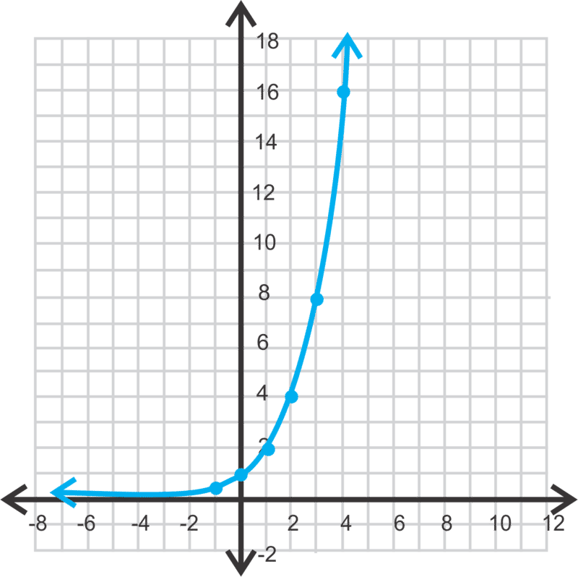**Identify the graph as exponential growth or exponential decay. Then find the domain and range.**

1. 2.

Growth or Decay (Circle one)

Domain:

Range:

Growth or Decay (Circle one)

Domain:

Range:

**Graphing Exponential Functions**

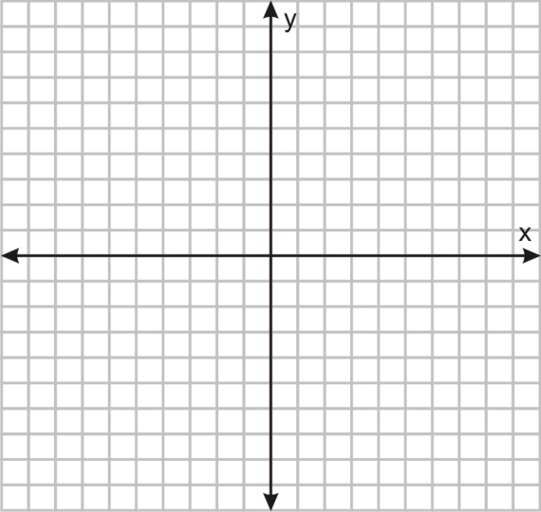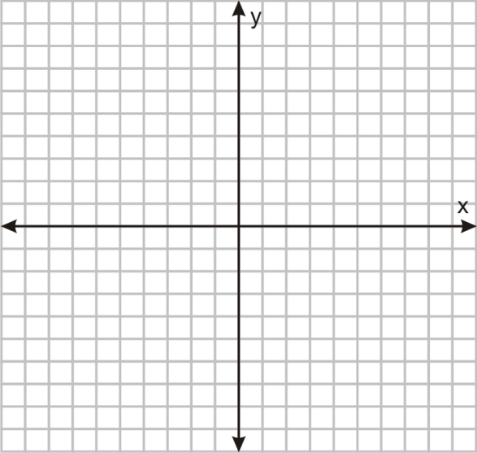3. $y=35 (.57)^{x}$ 4. $y=8 (3)^{x}$

Growth or Decay (Circle one)

Growth or decay factor:

Initial Value:

Domain:

Range:

Growth or Decay (Circle one)

Growth or decay factor:

Initial Value:

Domain:

Range:

****5. $y=4.5 (.95)^{x}$ 6. $y=1.3^{x}$

Growth or Decay (Circle one)

Growth or decay factor:

Initial Value:

Domain:

Range:

Growth or Decay (Circle one)

Growth or decay factor:

Initial Value:

Domain:

Range:

7. Looking at the equations in # 3-6, which equation shows the greatest growth? Explain.  
  
  
  
8. The population in 2012, of a small Upper Peninsula town was approximately 2,500. The   
 following equation can be used to model the change, *g*(*t*), over time, *t*, in years: *g*(*t*) = 2500(1.15)*t*

a. What does 2500 represent in this situation?  
  
 b. What does 1.15 represent in this situation?   
  
 c. Is the population increasing or decreasing?

d. What will be the predicted population in 2020?

9. A certain stock is worth $42 at the beginning of the day. Every hour the stock goes down by 5%.

a) Can this information be represented by exponential growth or decay? Explain.

b) What is the growth or decay factor for this information? Explain how you found it.

c) Write an equation to model this information. Explain what each part means.

d) How much will the stock be worth in 8 hours? Show work.

10. A dust bunny gathers dust at a rate of 11% per week. The dust bunny originally weighs 0.7 oz.

a) Write a function that represents the weight of the dust bunny at a given time. Use **x** for weeks   
 and **y** for the weight of the dust bunny.   
  
  
  
   
 b) Find the weight of the dust bunny after 7 weeks.

Final Exam Review – Semester 2 Name___________________________

Hour______

**THIS IS PART OF YOUR FINAL EXAM GRADE!!**

Part 2 - 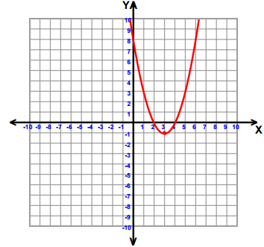Quadratic Functions

1. 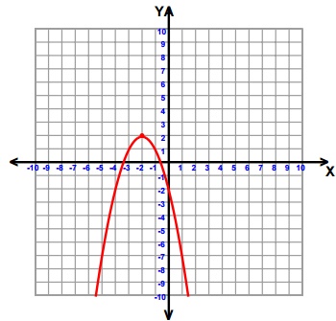

X- Intercept:

Y- Intercept:

Vertex:

Axis of Symmetry

Max or Min?

1. 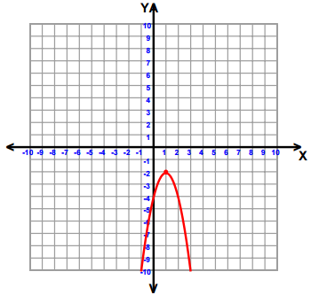

X- Intercept:

Y- Intercept:

Vertex:

Axis of Symmetry

Max or Min?

Zeros:

Y- Intercept:

Vertex:

Axis of Symmetry

Max or Min?

1. 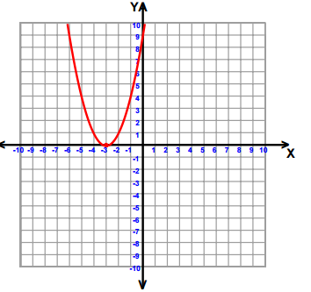

Roots:

Y- Intercept:

Vertex:

Axis of Symmetry

Max or Min?

**The following is a graph of the path of a rocket after it is launched.**

[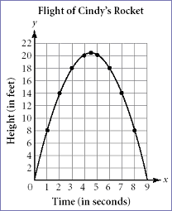](http://www.learner.org/workshops/algebra/workshop8/lessonplan1c.html)

5. Identify and explain the real world meaning of the following points. Height is in feet and time is in   
 seconds.

a) Vertex

b) x-intercept(s)

c) y-intercept(s)

6. How long does it take for the rocket to reach the **ground**?  
  
  
7. What will the height be in 6 seconds?

Final Exam Review – Semester 2 Name___________________________

Hour______

**THIS IS PART OF YOUR FINAL EXAM GRADE!!**

Part 3 – Solving Quadratic Equations

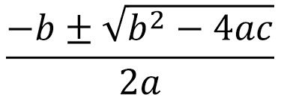**Solve each equation**

|  |  |  |
| --- | --- | --- |
| 1. Find the zeros by factoring. $$x^{2}-2x+8=0$$ | 2. Find the roots by factoring. $$x^{2}-7x+10=0$$ | 3. Find the x-intercepts by factoring. $$x^{2}+16x+64=0$$ |
| 4. Find the x-intercepts by taking  the square root. $$x^{2}-2=-2$$ | 5. Find the zeros by taking the  square root. $${4x}^{2}=-32$$ | 6. Solve by taking the square root. $$3x^{2}-2=241$$ |
| 7. Find the x-intercepts by  graphing. $${5x}^{2}+10x+20=0$$ | 8. Find the roots by graphing. $${2x}^{2}-x-21=0$$ | 9. Solve by graphing. $${3x}^{2}+8x-64=0$$ |
| 10. Solve by the quadratic  formula. $$2x^{2}+10x-48=0$$ | 11. Find the zeros using the  quadratic formula. $$3x^{2}-4x-132=0$$ | 12. Find the roots using the  quadratic formula. $$6x^{2}+4x-112=0$$ |
| 13. Find the roots. $$x^{2}-11x+10=0$$ | 14. Find the zeros of: $$x^{2}+6x-27=0$$ | 15. Solve the equation. $$2x^{2}+15x+28=0$$ |
| 16. Find all the zeros. $$2x^{2}-7x-13=0$$ | 17. Find the roots. $$6x^{2}+11x-112=0$$ | 18. Find the x-intercepts. |

8. Select the correct graph for the equation y= -(x– 1) (x - 7)





a.

b.



d.

c.

9. Select the correct graph for the equation y= 1/4 x2





a.

b.



c.

d.

10. Select the correct graph for the equation y=x2 - 4x + 4





a.

b.



d.

c.

11. Select the correct graph for the equation y=-2(x – 2)2 - 4

|  |  |  |  |
| --- | --- | --- | --- |
| c.  a. |  |  | d.  b. |

12. **P = 2l + 2w** Solve for **w**. 13. **P = 2l + 2w** Solve for **l**.  
  
  
  
  
  
14. **n = 4m + 2** Solve for m. 15. $A=\frac{1}{2}bh$ Solve for **b.**

**Determine the roots/zeros**

16. 17.

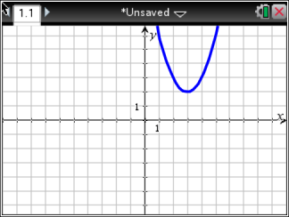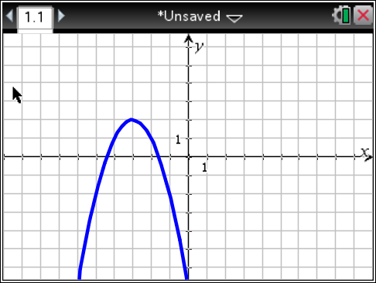  
  
  
**Identify the vertex of each and describe if it is a maximum or minimum**   
  
18. 19.   
  
  
  
20. 21.

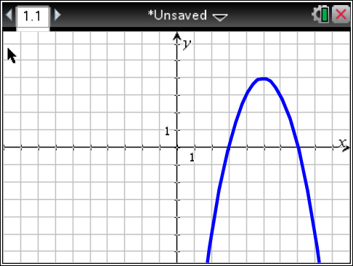22. 23. $f\left(x\right)=-(x-3)^{2}$  
  
  
  
**Determine the number of solutions**

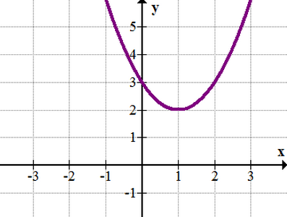

24. 25.

Final Exam Review – Semester 2 Name___________________________

Hour______

**THIS IS PART OF YOUR FINAL EXAM GRADE!!**

Part 4 - Polynomials

|  |  |
| --- | --- |
| 1. Simplify | 2. Simplify |
| 3. Simplify | 4. Simplify |
| 5. Simplify  (-3x+2y)2 | 6. Simplify |

|  |  |
| --- | --- |
| 7. Simplify | 8. Simplify |
| 9. Simplify | 10. Simplify  (-4x2+5x-8)-(-x2+3x+6) |
| 11. Simplify | 12. Simplify |