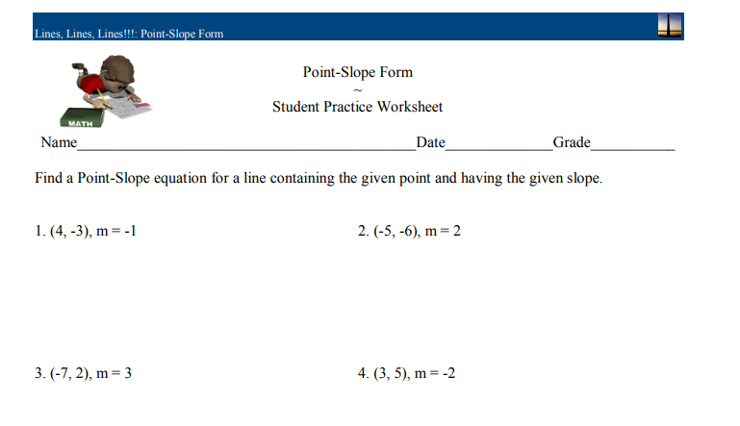

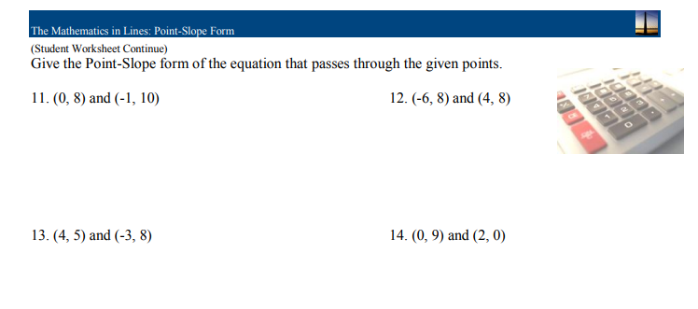

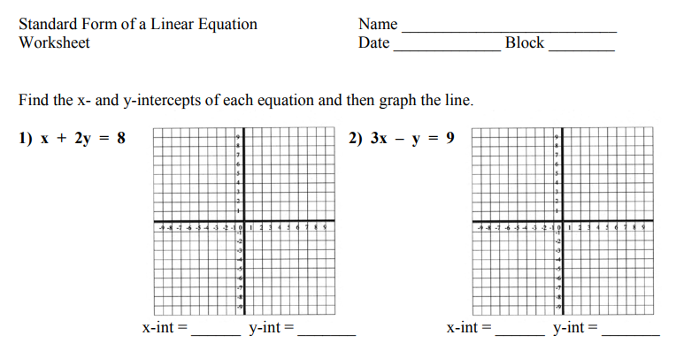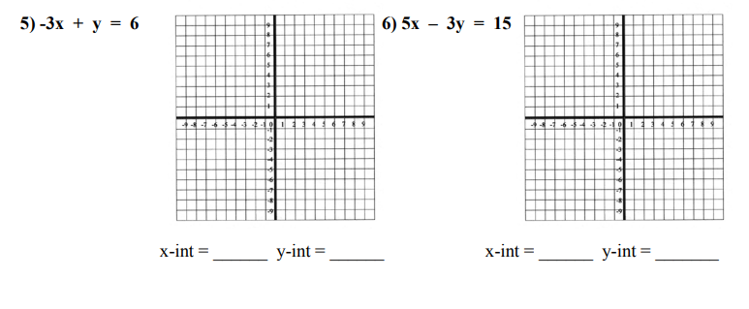

7) Abby is buying some pop and some water. She has $30 to spend. The pop costs $3 per bottle

and the water costs $1 per bottle.

a) Write an equation to show this relationship.

b) If Abbey buys 6 bottles of pop, how many bottles of water can she buy?