Linear or Not? Name ________________________

Date ______________ Hour ______

For each table, find the rate of change to determine if the relationship is linear or not.

(HINT: Is the rate of change constant?)

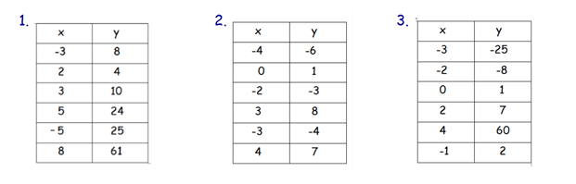

Linear or Not Linear? Linear or Not Linear? Linear or Not Linear?

4)

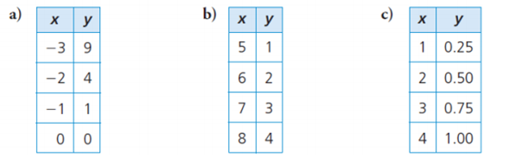

Linear or Not Linear? Linear or Not Linear? Linear or Not Linear?