Domain and Range Practice Name __________________

Learning Target: I can use the correct notation for the solution set of a function.

For each problem:
- State the domain and range using the correct notation.
- Determine if the relation represents a function.
- Explain your answer.

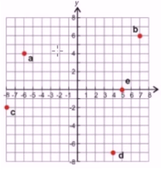  Domain:__________________  Range:___________________  Function: YES NO  Explanation: _________________  __________________________ | 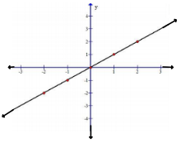  Domain:__________________  Range:___________________  Function: YES NO  Explanation: _________________  __________________________
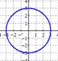  Domain:__________________  Range:___________________  Function: YES NO  Explanation: _________________  __________________________ | 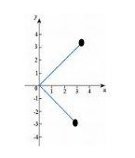  Domain:__________________  Range:___________________  Function: YES NO  Explanation: _________________  __________________________
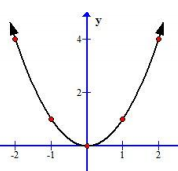  Domain:__________________  Range:___________________  Function: YES NO  Explanation: _________________  __________________________ | 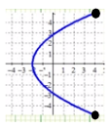  Domain:__________________  Range:___________________  Function: YES NO  Explanation: _________________  __________________________
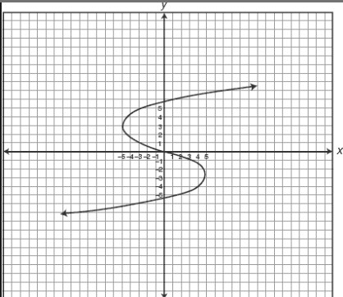  Domain:__________________  Range:___________________  Function: YES NO  Explanation: _________________  __________________________ | 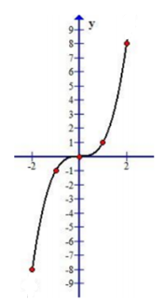  Domain:__________________  Range:___________________  Function: YES NO  Explanation: _________________  __________________________

