Domain and Range Practice 2 Name __________________

Learning Target: I can use the correct notation for the solution set of a function.

For each problem:

1. State the domain and range using the correct notation.
2. Determine if the relation represents a function.
3. Explain your answer.

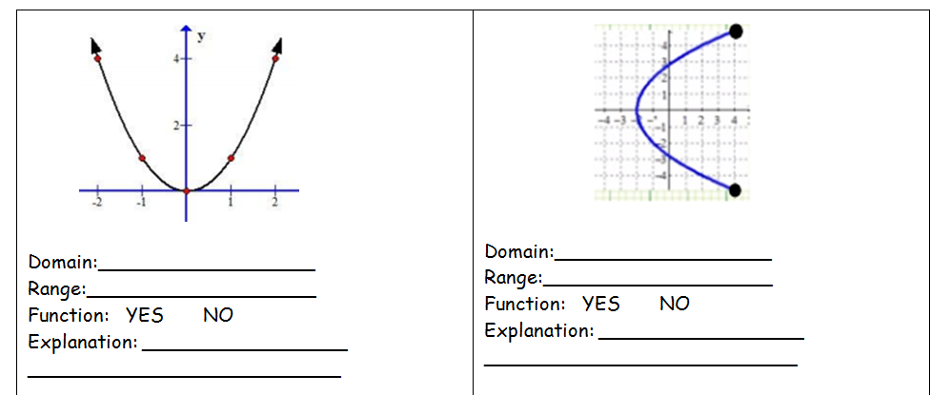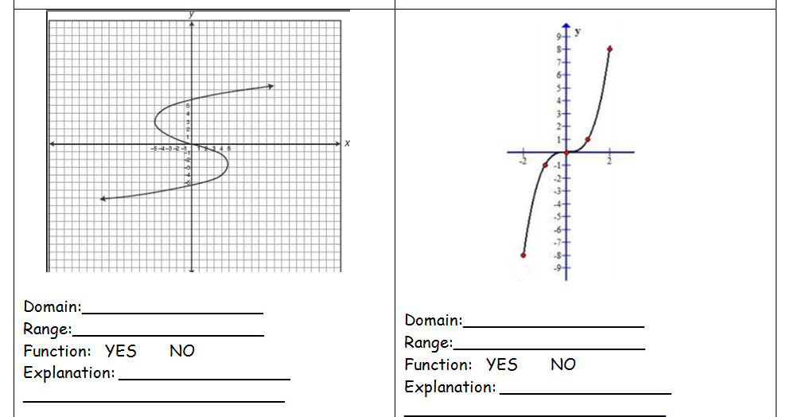

5) 6)

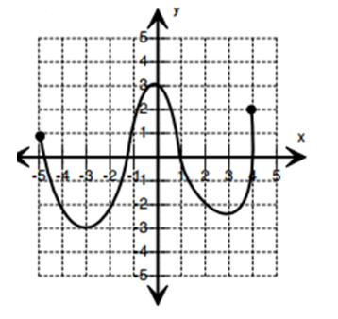 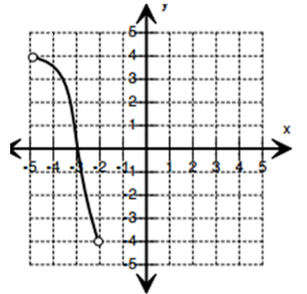

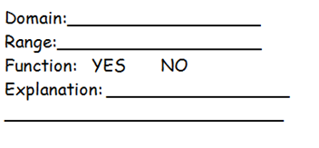 

7) 8)

