Algebra 1 Name _____________________

6-1 Rate of Change and Slope Date ______________ Hour ___

Find the rate of change in each table below. Show your work. Explain what the rate of change means in each example.

1) 2)

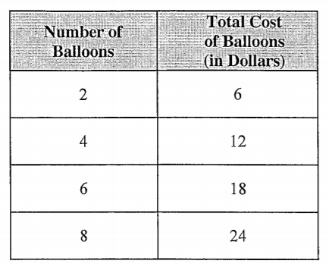 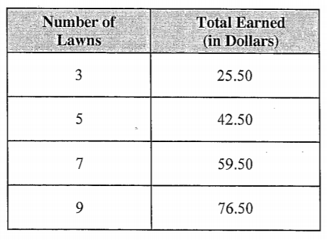

Rate of change _________________ Rate of change ___________________

Explanation ____________________ Explanation ______________________

3) 4)

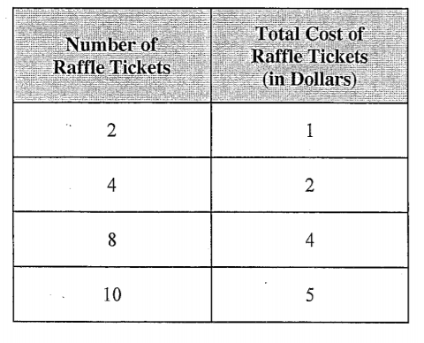 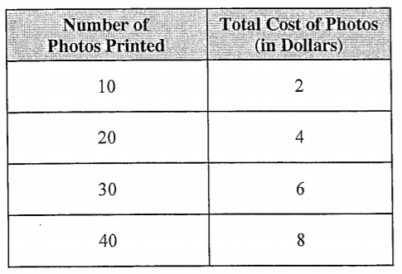

Use the slope formula, , to calculate the slope from each table. Show your work.

5) 6)

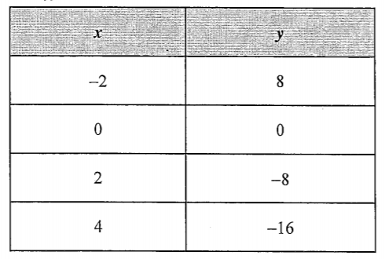 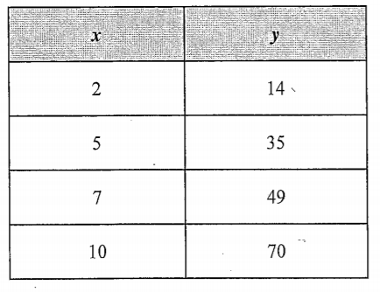

Slope = ________________ Slope = _________________

Use the slope formula, ,to find the slope of the line containing the two given points. Show your work.

7) (-4, 1), (6, 3) 8) (-3, 2), (-9, 4) 9) (0, 1), (-3, 4)

Find the slope of each line. 

10) 11)

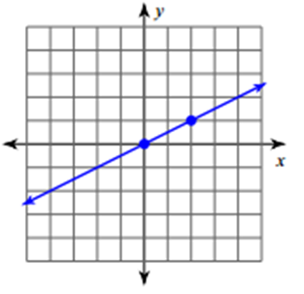 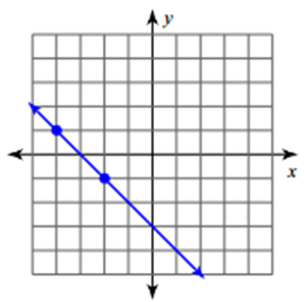

12) 13)

