Hold Up Your Answers – Solving Quadratic Equations Name _______________________

**1) Graph the equation. Label the vertex and the axis of symmetry.**

**y = -x² + 2x + 1**

**2) Solve using square roots. x² = 49**

**3) Solve using square roots. 2x² = 12**

4**) Solve using square roots. 2x² + 8 = 0**

5) **Use the zero product property to solve the equation.**

**(x + 3)(x - 5) = 0**

**6) Solve each equation by factoring. (Use the x-method.)**

**x² - 7x - 18 = 0**

**For #7 and 8, solve the equation using the quadratic formula.**

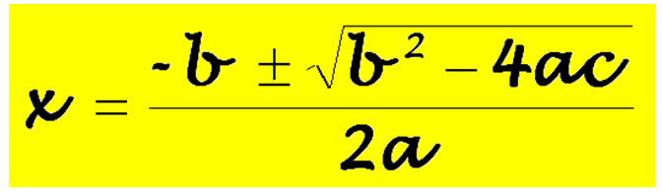

**7) 5x² - 9x - 5 = 0**

**8)**  