**Algebra 1 Semester 2 Study Guide Name ___________________________**

**Part 1 – This is part of your exam grade.**

**Systems of Linear Equations – I can write and solve systems of linear equations.**

1. Solve each system of equations:

a) 

b) 

c) 

**Write and solve a system of linear equations for each problem below.**

2. On Mr. Wood’s farm, he raises chickens and cows. There are 34 animals in all. Mr. Wood counts 110 legs on

these animals. Find the number of each type of animal.

3. A test has 24 questions worth 100 points.  The true/false questions are worth 4 points each and the multiple

choice questions are worth 5 points each.  How many of each type of question are on the test?

4. Emma is throwing a party! She buys 3 rolls of streamers and 15 party hats for $30. Later, she buys 2 more

rolls of streamers and 4 more party hats for $11. Find the cost of each roll of streamers and each party

hat.

**Exponents– I can simplify exponential expressions.**

Simplify each expression.

5.  6.  7. 

8.  9. 10. 

11.  12.  13. 

**Exponential Functions – y = ab x**

**Remember: a = the initial amount (the y-intercept) b = the growth factor - if 0 < b < 1 this shows decay**

**- if b > 1 this shows growth**

**For #1-3, tell:**

**a) if the equation represents growth or decay (circle one) d) the initial value (what is the value of a?)**

**b) the growth or decay factor (what is the value of b?) e) graph the function**

**c) the percent of growth or decay (what is the difference f) tell the domain and range**

**between b and 1? (1 + r) or (1 – r)**

1. 2. 3.

  

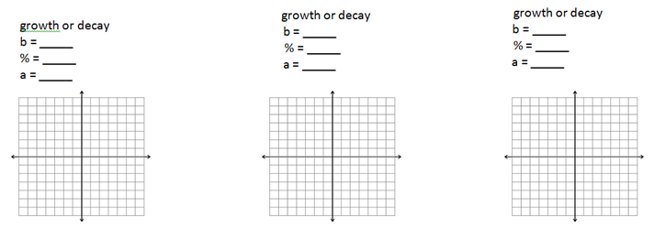

5. Of #2 – 4, which shows the greatest growth? Explain.

6. The price of a new car is $46,500. The value of the car depreciates at a rate of 7% per year. The following

equation can be used to model the price of the car over time, *x*, in years: *f(x)* = 45,500(.07)*x* .

a) What is the car worth after 5 years?

b) After 36 months?

7. A dust bunny gathers dust at a rate of 11% per week. The dust bunny originally weighs 0.7 oz.

a) Write a function that represents the weight of the dust bunny at a given time. Use x for weeks   
 and y for the weight of the dust bunny.

b) Find the weight of the dust bunny after 7 weeks.

**Algebra 1 Semester 2 Study Guide Name ___________________________**

**Part 2 – This is part of your exam grade.**

**Quadratic Functions**

**For 1 – 4,**

**a) Find and label the y-intercept .**

**b) Find and label the x-intercept(s)/zero(s)/root(s)/solution(s). c) Identify and label the vertex.**

**d) Is the vertex a maximum or a minimum?**

**e) Draw in the axis of symmetry and write the equation for it.**

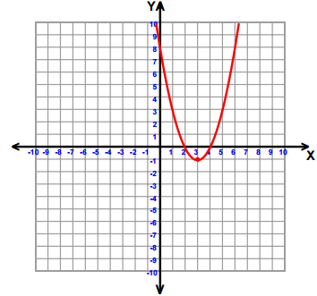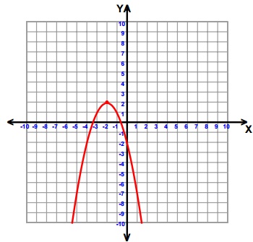 1. 2.

3. 4.

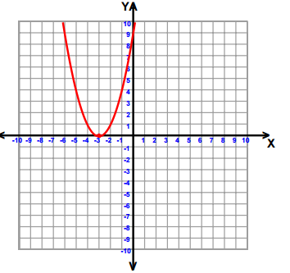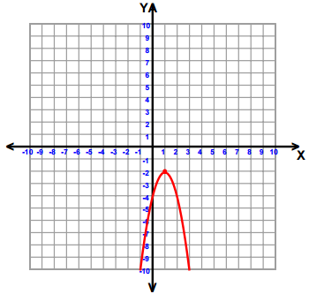

**Factor each expression for 5 – 8.**

5.  6.  7.  8. 

**The following is a graph of the path of a rocket after it is launched.**

[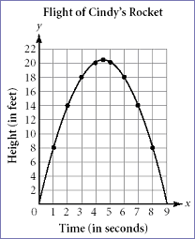](http://www.learner.org/workshops/algebra/workshop8/lessonplan1c.html)

9. Identify and explain the real world meaning of the following points. Height is in feet and time is in   
 seconds.

a) Vertex b) x-intercept(s) c) y-intercept(s)

10. How long does it take for the rocket to reach the **ground**? Explain your answer.

**For 11 - 14, graph each quadratic function.**

11.  12.  13.  14. 

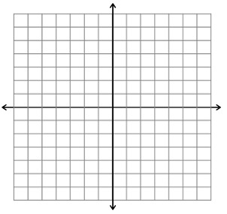   

15. Explain what can be determined by looking at each form of a quadratic function.

a) Standard  b) Factored  c) Vertex 

**Algebra 1 Semester 2 Study Guide Name ___________________________**

**Part 3 – This is part of your exam grade.**

**Quadratic Functions**

1. What is the vertex of g(x) = (x – 3)2 + 2 ?

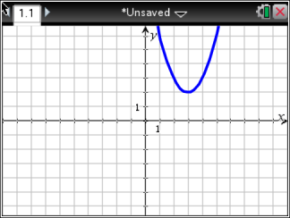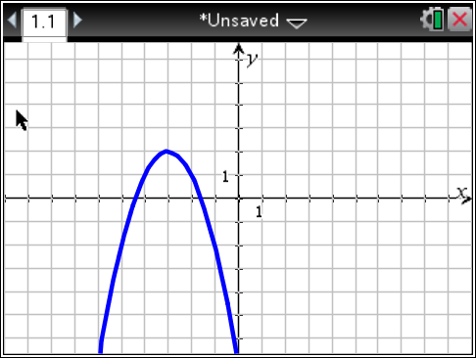

Which of the following has the **same vertex** as g(x)? There may be more than one correct answer.

a) h(x) = -2(x – 3)2 – 2 b) f(x) = (x + 3)2 + 2 c) p(x) = x2 – 6x + 11 d) q(x) = (x – 3)(x + 2)

e) f)

Determine the number of solutions for the following quadratic functions in questions 17 and 18. What are the solutions?

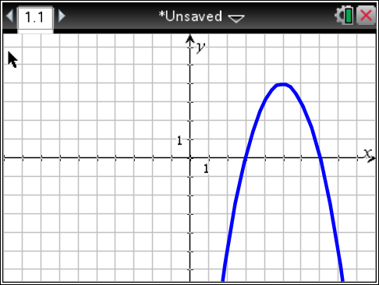2. 3.

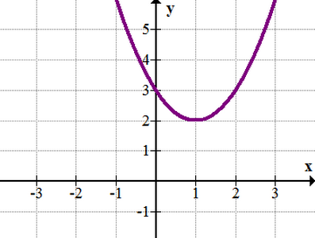

**For 4 - 11, round answers to the nearest hundredth if necessary.**

4. Find the roots of . 5. Find the zeros of .

6. Solve the equation . 7. Solve .

8. Find all of the zeros of . 9. Find the roots of .

10. Find the solutions to . 11. Solve .

**Polynomial Review**

**Find the sum, difference or product of each for 1 – 12.**

1.  2.  3.  4. 

5.  6.  7.  8. 

9.  10.  11.  12. 

13. a) Write an expression for the perimeter of the figure below.

b) Write an expression for the area of the figure below.

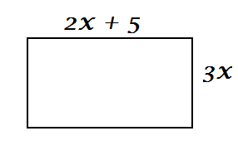

14. The surface area, , of a right circular cylinder is calculated using the formula ,   
 where *r* is the radius of the cylinder and *h* is the height of the cylinder. Rearrange the formula to   
 solve for height (*h*).

15. If denotes a temperature in degrees Fahrenheit and  is the same temperature measured in   
 degrees Celsius, then  and  are related by the equation . Rewrite this equation to   
 solve for  in terms of .