Vertex Form Graphing Extra Practice Name: ____________________
Graph the equation. Label the vertex and axis of symmetry. Include your table of values for your extra points.  y = -2(x + 2)² - 5  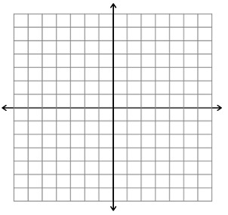 | Graph the equation. Label the vertex and axis of symmetry. Include your table of values for your extra points.  y = (x - 1)² - 3
Graph the equation. Label the vertex and axis of symmetry. Include your table of values for your extra points.  y = (x + 3)² + 2 | Graph the equation. Label the vertex and axis of symmetry. Include your table of values for your extra points.  y = 2(x - 2)² - 2
Graph the equation. Label the vertex and axis of symmetry. Include your table of values for your extra points.  y = -4(x + 2)² + 1 | Graph the equation. Label the vertex and axis of symmetry. Include your table of values for your extra points.  y = -(x - 1)² - 1

- What is the shape of a quadratic graph?

- What is vertex form of a quadratic function?

- How does the “k” value affect a quadratic graph?

- How does the “a” value affect a quadratic graph?

- How does the “h” value affect a quadratic graph?

- What information can you use from the vertex form of a quadratic equation to help you picture or draw the shape of the graph?

