Practice 7-1 Name ___________________________

Solving Systems by Graphing

Solve each system by graphing. Use a graphing calculator or graph by hand. Sketch out the graph for each system. If there is a **solution**, label it clearly on the graph. If there is **no solution** or **an infinite number of solutions,** label it clearly on the graph.

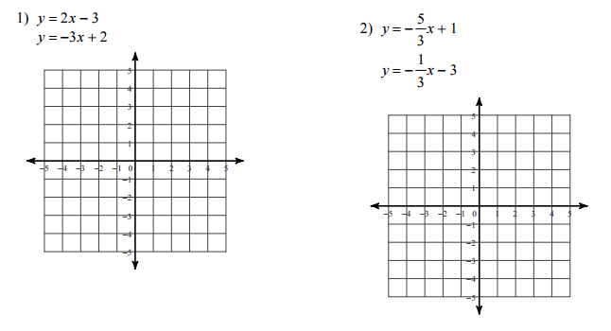

3) 4)

 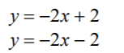

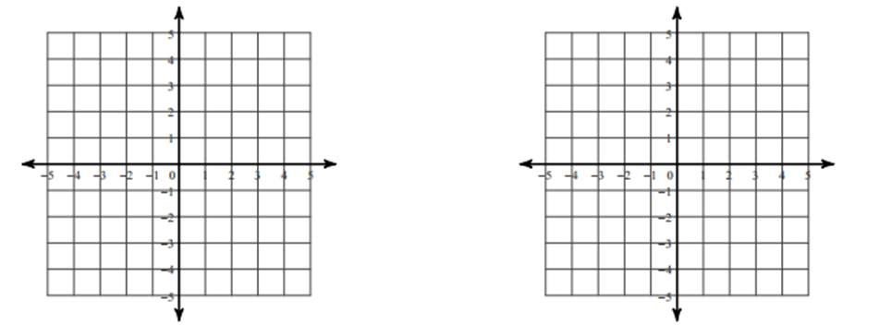

5) x + 4y = 3 6) y = - ¼ x + 3

2x + 8y = 6 x + 4y = -2

