**Review – Chapter 3 Name ___________________________**

**Date _______________ Hour ________**

**Section 3-1**

Write an inequality for each graph.

1) 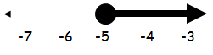 2) 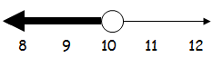

3) **Define a variable** and write an inequality to model this situation.

There was less than seven inches of snowfall last night.

**Sections 3.2 and 3.3 -** Solve each inequality. Then graph the solution.

4) x - 5 < 17 5) y + 2 > 4 6) -3k < -32

7)  8) 

**Section 3-4 - Solve and check each inequality.**

9) 2z + 7 < z + 10 10) 4(k – 1) > 4 11) 13t – 8t > -45

12) h + 2(3h + 4)> 1 13) r + 4 > 13 – 2r 14) 6x – 18 – 4x < 22