ROUND TABLE REVIEW – Part 1 - Section 6-1
1) The rate of change in the table is constant.
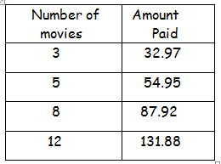
a) Find the rate of change.

b) What does the rate of change represent?
2) Find the slope of each line. ($\frac{\text{rise}}{\text{run}}=\frac{y_{2}−y_{1}}{x_{2}−x_{1}}$ Count up and over).
a) b)
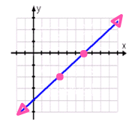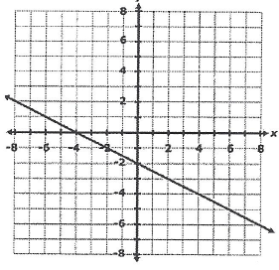
3) Find the slope of the line containing each pair of points.

a) (4, -1), (-3, 7) b) (1, -5), (1, 4) c) (4, -3), (-5, -7) d) (-4, 6), (2, 6)

ROUND TABLE REVIEW - Part 2 - Section 6-2

(Remember slope-intercept form: y = mx + b; m = slope and b = y-intercept.)
Identify the slope and y-intercept for each equation.
1) y = 2x + 3 2) y = 3 – ¼ x

3) Write the equation of the line with slope 2 and y-intercept -1.

4) Find the slope and write an equation for each line shown below.
a) b) c) d)
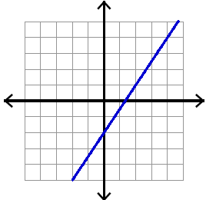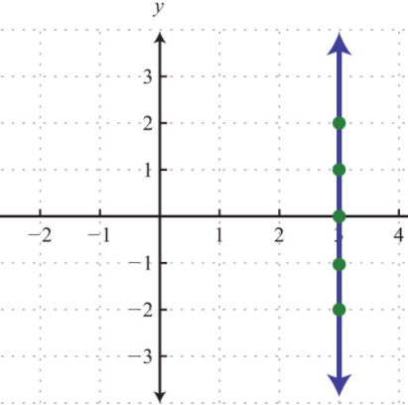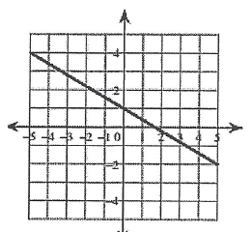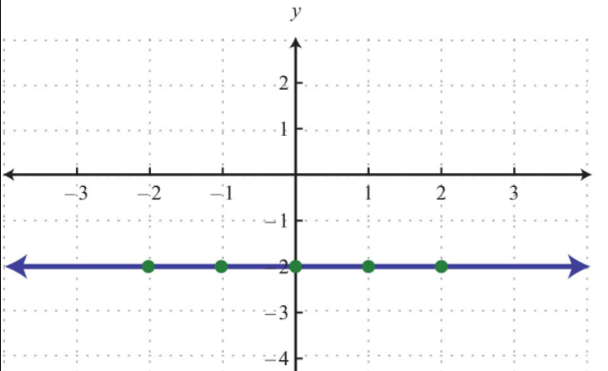

ROUND TABL
E REVIEW - Part 3 - Section 6-2
Graph each equation and tell what the slope of the line is.

1) y = -3x – 4 2) Graph y = -2 3) Graph x = 4
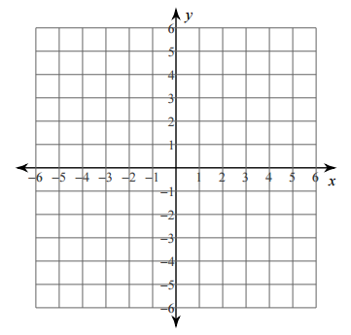

ROUND TABLE REVIEW - Part 4 - Section 6-2
Find the missing coordinate for each set of points with the given slope.
1) (x, 6), (-3, -3); m = -3 2) (5, y), (-4, 7); m = -4/9 3) (-2, -4), (x, 2); m = 3/4

