Name Class Date

Practice 6-1 Rate of Change and Slope

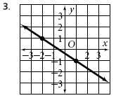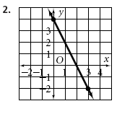**Find the slope of each line.**

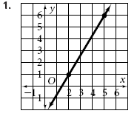

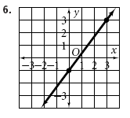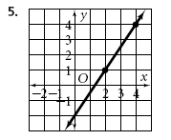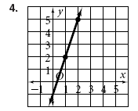

**Find the slope of the line that passes through each pair of points.**

**7.** (1, 2), (4, 3) **8.** (7, 2), (3, 5) **9.** (0, 2), (4, 6)

**10.** (–2, 5), (3, –4) **11.** (2, 4), (6, 7) **12.** (–2, –5), (4, 5)

**Find the rate of change. Explain what the rate of change means for each situation.**

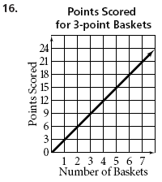 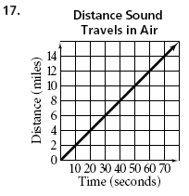 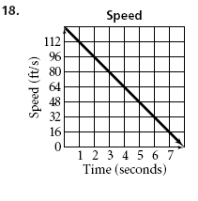

Practice 6-2 Slope-Intercept Form

**Find the slope and y-intercept of each equation. Then graph.**

**1.** *y* = *x* + 2 **2.** *y* + 3 =  **3.** *y* = 2*x* – 1

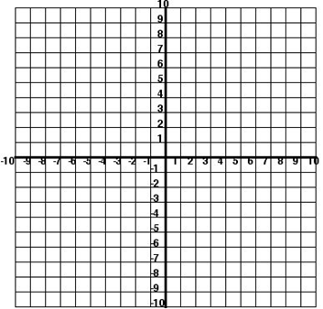  

**4.** *y* =  – 4 **5.** *y* – 2*x* = –3 **6.** *y* = *x*+ 3



**Write the slope-intercept form of the equation for each line.**

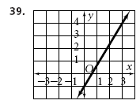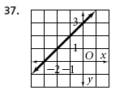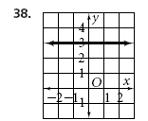

slope ____________ slope ____________ slope ____________

y-intercept _______ y-intercept _______ y-intercept _______

equation _________ equation _________ equation _________