Algebra 1 Name ___________________
6- 4 Point-Slope Form Date _________ Hour ______

For each equation, identify the x- and y-coordinates of the given point. Graph the point and label its coordinates. Then use the slope to graph another point. Connect the points to make the line.

1. y – 4 = 4(x – 1) 2. y – 3 = ¼ (x – 4)
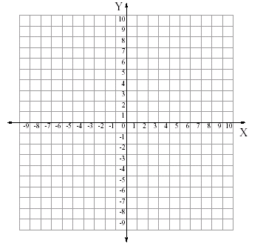

3. y – 2 = -2/5 (x – 4) 4. y + 1 = - ¾ (x – 3)

5. y – 5 = -2/3 (x – 6) 6. y – 5 = 4/3 (x + 4)

