Algebra 1 Name _____________________

Date _____________ Hour ____

**Is It Linear or Non-Linear?**

Tell whether the x-y relationship in each table, graph or equation is linear or non-linear. Explain your answer.

1) 2) 3)

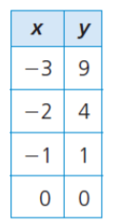 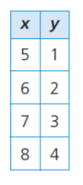 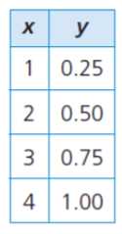

Linear or Non-linear Linear or Non-linear Linear or Non-linear

Explain Explain Explain

4) 5) 6)

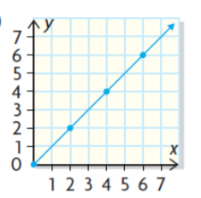 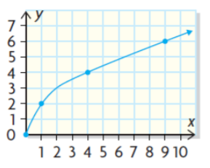 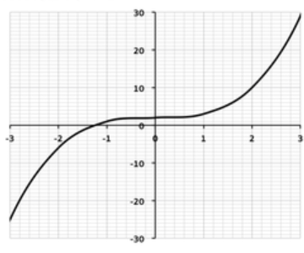

Linear or Non-linear Linear or Non-linear Linear or Non-linear

Explain Explain Explain

7) 8) 9)

**y = -3x – 4 y = 5x² + 2 y = ½ x + 6**

Linear or Non-linear Linear or Non-linear Linear or Non-linear

Explain Explain Explain

10) On the back of this paper, make your own table or equation that represents a linear relationship.

Explain how you know it is linear.