Algebra 1 Name ________________________

Review 6.3-6.4 Date ______________ Hour ______

**Use your notes!!**

Determine if each equation is in slope-intercept, point-slope, or standard form.

1. 2x - 4y = 5 2. y – 3 = -3(x - 4) 3. y = 3x - 4

__________________ _________________ ________________

Determine if each table is linear or not. If it is, write an equation in slope-intercept form.

4. 5.

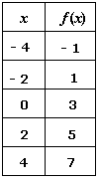 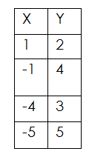

6. Use the point and the slope **or** the two points given to write an equation in **point-slope form**.

Then rewrite the equation in **slope-intercept form**.

a. (-4, 2) m = 4 b. (-2, 3) (5, -4) (find slope first!)

point-slope equation: __________________ point-slope equation: _______________

slope-intercept equation: _______________ slope-intercept equation: ____________

7. Determine the point and slope from the equation  
  
a. y - 3 = -3(x – 3) b. y + 3 = 4(x + 2) c. y + 5 = ½x

point ________ point _________ point ________

slope _______ slope ________ slope ________

8. Write an equation in point-slope form. Use the coordinate on the right to write your equation.

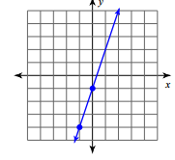a. 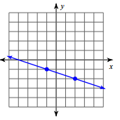 b.

9. Point-Slope Form. Use the point and the slope to graph each equation.

a. y - 4 = -1/2(x - 3) b. y + 2 = -3(x + 2) c. y - 4 = 2(x + 1)

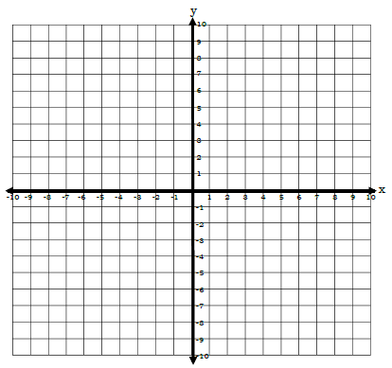

m = m = m =  
(x1, y1) = (x1, y1) = (x1, y1) =



10. Standard Form. Use the x- and y-intercepts to graph each line.

a. 3x + 2y = -6 b. 2x – 3y = -6 c. 3x – y = 3



Write and solve an equation in standard form for each situation.

11. You are in charge of buying food for your family reunion. You pay $1.50 for each hamburger and

$2 for each hotdog.

a. Define variables for the number of hot dogs and hamburgers you buy.

b. Write an equation in standard form to relate the number of hamburgers and hot dogs you must

buy to stay in your $90 budget.

c. If you bought 30 hot dogs, how many hamburgers did you buy?

12. You are selling drinks at the carnival to raise money for your school club. You sell lemonade for

$2 per cup and orange drinks for $3 per cup.

a. Define variables for the number of lemonade and orange drinks you sell.

b. Write an equation in standard form to relate the number of lemonade and orange drinks you

must sell to raise $240.   
  
  
c. If you sell 60 cups of lemonade, how many cups of orange drink did you sell?