Algebra 1 **SHOW ALL WORK** Name _______________________
Functions – Practice Test Date Hour

Learning Target – I can evaluate a function.

1. Evaluate f(x) = 3x² + 5 for f(-2). (2 points) Answer ____________

2. Evaluate f(x) = -5x + 5 for f(6). (2 points) Answer ____________

Learning Target – I can determine whether an ordered pair is a solution to the function or not.

3. For the following input/output table, determine which of the following ordered pairs are solutions to the
function h(x) = ½ x + 4. Write YES or NO for each one. (2 points each)

x | h(x) | h(x) = ½ x + 4  Show work here. | YES  or  NO
-4 | 2
0 | -1
-10 | -9

Learning Target – I can determine whether a relation is a function and identify the domain and range. (3 pts.each)

4) {(-3, 7), (0, 5), (-3, 2), (2, 6)

DOMAIN:
RANGE:

FUNCTION: YES or NO

Reason:

6)
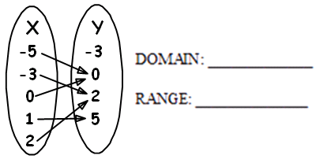
FUNCTION: YES or NO
Reason:

5)
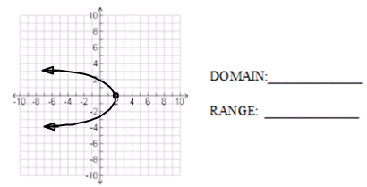

FUNCTION: YES or NO
Reason:
7)
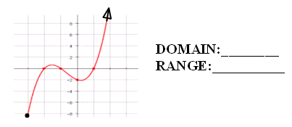
FUNCTION: YES or NO
Reason:

Learning Target – I can identify increasing, decreasing and constant intervals on a graph.

8) 9)

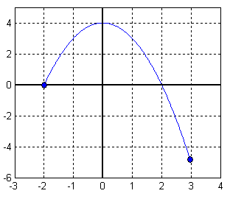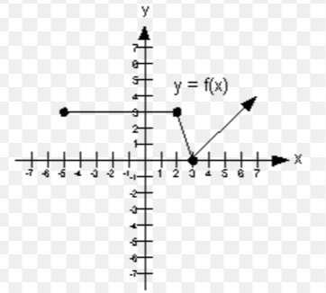

Increasing: ___________________ Increasing: ________________
Decreasing: __________________ Decreasing: ________________
Constant: ____________________ Constant: __________________

Learning Target: I can explain the vertical line test using domain and range.

10. Part 1: Explain how the vertical line test determines if a relation is a function. Use the terms
domain and range in your explanation. (2 points)
______________________________________________________ ___________
___________________________________________________________________
___________________________________________________________________

Part 2: Provide an example of a relation that is a function and an example of a relation that is
not a function. (2 points each)

Function Not a Function

Learning Targets: I can write an equation in function notation.

I can create a table of values and graph the equation that represents a function.

11) Graph the function: $y=2x+1$.

Part 1: Write the function in function notation:___________. (1 point)

Part 2: Create a table of values with at least 5 values for the domain (5 points).

DOMAIN (x) | FUNCTION  $$y=2x+1$$ | ORDERED PAIRS
-2
-1
0
1
2

Graph the function. (2 points)

