Name Class Date
Practice 5-3 Function Rules, Tables, and Graphs
Make a table of values for each equation and graph the equation.
1. ƒ(x) = x + 1 2. ƒ(x) = 2x
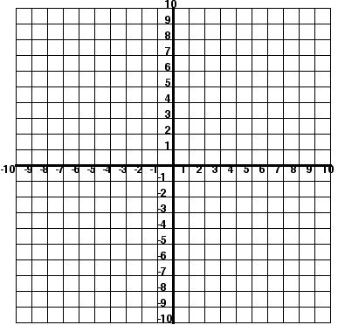
3. ƒ(x) = 3x – 2 4. f(x) = x

5. ƒ(x) = 4x + 2 6. ƒ(x) = –3x + 7

Use set notation or interval notation to describe the domain and range of each function below. Use your notes!!

1) 2) 3) 4)
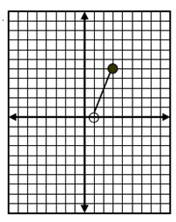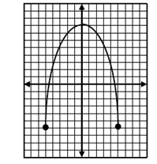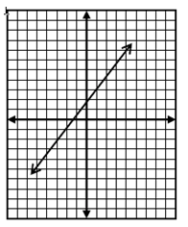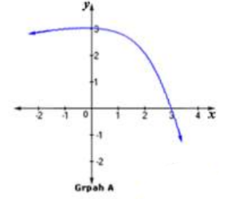
Domain: _________ Domain: ________ Domain: _______ Domain: __________
Range: __________ Range: _________ Range: ________ Range: ___________

5) 6) 7) 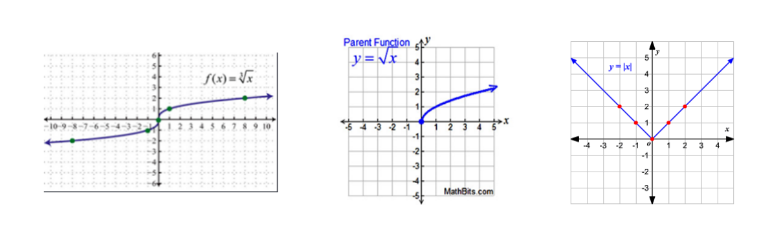 Domain: _________ Domain: ________ Domain: _______
Range: __________ Range: _________ Range: ________

8) 9) 10) 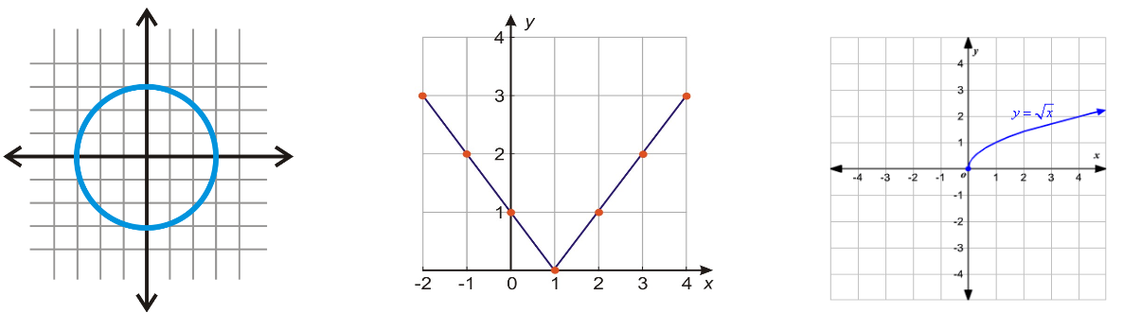
Domain: _________ Domain: ________ Domain: _______
Range: __________ Range: _________ Range: ________

