Name Class Date
Practice 5-2 Relations and Functions
Find the domain and range of each relation.
1. {(–3, –7), (–1, –3), (0, –1), (2, 3), (4, 7)} 2. {(–5, –4), (–4, 2), (0, 2), (1, 3), (2, 4)}

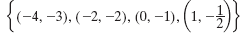
Determine whether each of the following relations is a function.
3. 4. {(0, 0), (1, 1), (4, 2), (1, –1)}

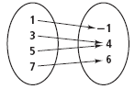
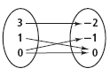
5. 6.

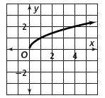
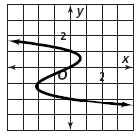
7. 8.

Evaluate each function rule(equation) for x = 3.
9. ƒ(x) = 2x – 15 10. ƒ(x) = –x + 3

11. g(x) = x – 1 12. h(x) = –x –

13. h(x) = –0.1x + 2.1 14. g(x) = – +
Evaluate each function rule(equation) for x = –.
15. ƒ(x) = 4x – 2 16. ƒ(x) = –x + 1
17. g(x) = – + 3 18. h(x) = x –
Find the range of each function for the given domain.
19. ƒ(x) = –3x + 1 for f(-2) 20. ƒ(x) = x² + x – 2 for f(0)

21. h(x) = –x² for f(–3) 22. g(x) = – + 1 for f(–1)

