**Notes 6-1** continued again Name _______________

Example – not in your book

Learning Target -

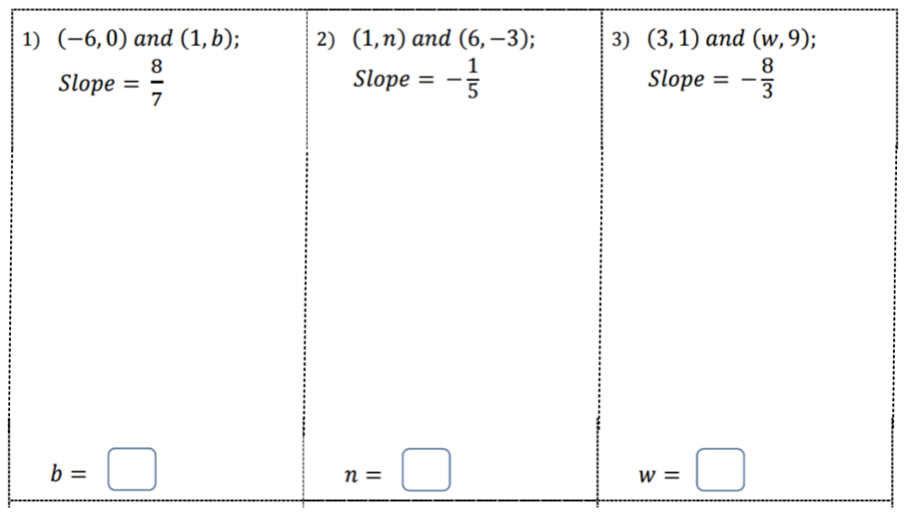

**Notes 6-1** continued again Name _______________

Example – not in your book

Learning Target -



**Notes 6-1 Try these on your own.**

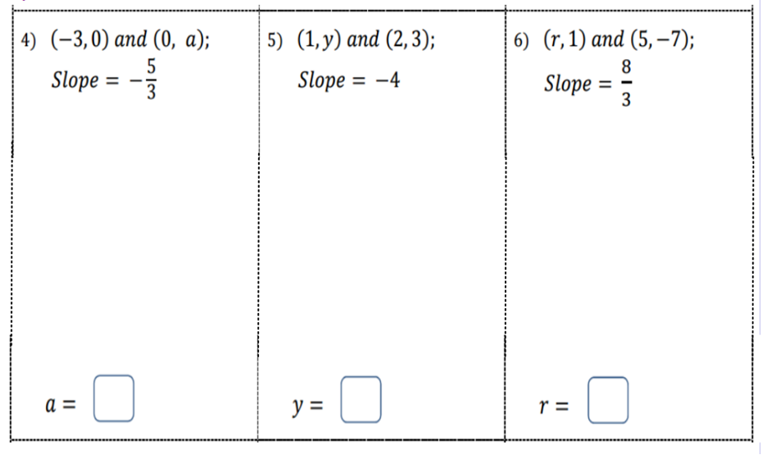

**Notes 6-1 Try these on your own.**



**Notes 6-1 - Horizontal and Vertical Lines**

**Learning Target –**

**Example 5 - Find the slope of each line.**

**Choose 2 points on each line and use the slope formula  to find the slope.**

**a. b.**

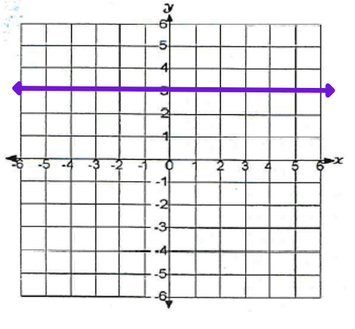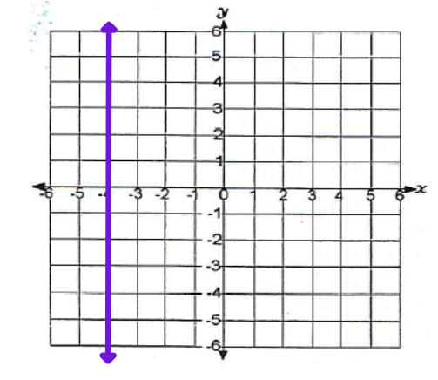

**Notes 6-1 - Horizontal and Vertical Lines**

**Learning Target –**

**Example 5 - Find the slope of each line.**

**Choose 2 points on each line and use the slope formula  to find the slope.**

**a. b.**

