Algebra 1 **SHOW ALL WORK** Name _______________________
Function Review Date Hour

Learning Target – I can evaluate a function.

- Evaluate f(x)= 3x + 4 for f(-2)
- Evaluate f(x)= -7x - 2 for f(5)
- Evaluate f(x)= 5x - 7 for f(-3)

Learning Target – I can determine whether an ordered pair is a solution to the function or not.

4. For the following input/output table, determine which of the following ordered pairs are solutions to the
function f(x) = 3x - 7. Write YES or NO for each one. If yes, write the solution as an ordered pair.

x | f(x) | f(x) = 3x -7  Show work here. | YES  or  NO
4 | 5
6 | 8
2 | -1
5. For the following input/output table, determine which of the following ordered pairs are solutions to the
function f(x) = ½ x +5. Write YES or NO for each one. If yes, write the solution as an ordered pair.

x | f(x) | f(x) = ½ x +5  Show work here. | YES  or  NO
0 | 6
-4 | 3
8 | 9

Learning Target – I can determine whether a relation is a function and identify the domain and range.

7.

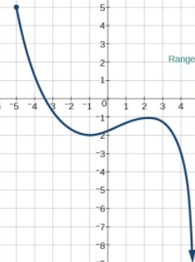
6) {(-2, 4), (-3, 5), (-2, 3), (-5, 2)}

DOMAIN:
RANGE:

FUNCTION: YES or NO

Reason: _____________________
__________________________
8.
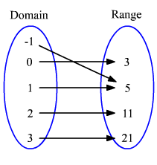
DOMAIN:___________ 9)
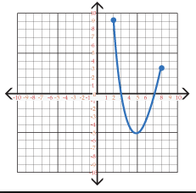
RANGE:_____________

FUNCTION: YES or NO
Reason:_________________
______________________

DOMAIN:_____________
RANGE:_______________

FUNCTION: YES OR NO

Reason:_______________
_______________________

DOMAIN:___________
RANGE:_____________

FUNCTION: YES or NO
Reason:_________________
______________________

6) {(
10) {(2, 8), (3,-2 ), (2, 7), (5, -2)}

DOMAIN:
RANGE:

FUNCTION: YES or NO

Reason: _____________________
__________________________
DOMAIN:___________
RANGE:_____________ FUNCTION: YES or NO
Reason:_________________
______________________

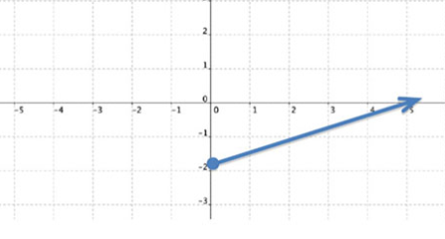
11)

DOMAIN:___________
RANGE:_____________ FUNCTION: YES or NO
Reason:_________________
______________________

12)
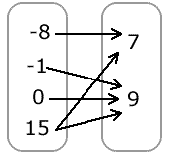

Learning Goal: I can identify increasing, decreasing and constant intervals on a graph.

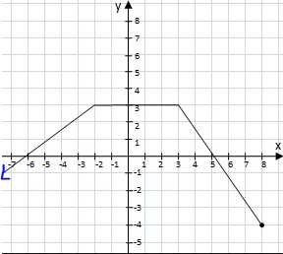
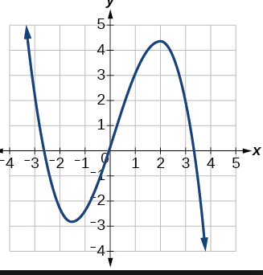
13) 14)

Increasing:______________ Increasing:_______________
Decreasing:______________ Decreasing:______________
Constant:________________ Constant:______________
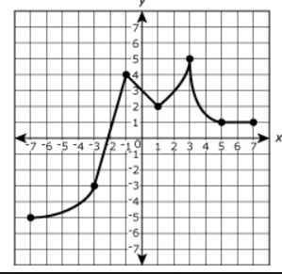
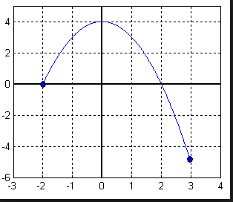
15) 16)

Increasing:______________ Increasing:_______________
Decreasing:______________ Decreasing:______________
Constant:________________ Constant:______________

Learning Target: I can explain the vertical line test using domain and range.

17. Explain why the vertical line test determines if a relation is a function or not.

______________________________________________________ ___________
___________________________________________________________________
___________________________________________________________________

Learning Targets: I can write an equation in function notation.

I can create a table of values and graph the equation that represents a function.

10) Graph the function: $y=\text{x -5}$.

Part 1: Write the function in function notation:___________.

Part 2: Create a table of values with at least 5 values for the domain

DOMAIN (x) | FUNCTION  $$\text{y }=\text{ x -5}$$ | ORDERED PAIRS

Graph the function.

