1.) Write a quadratic equation in vertex form if a = 1, h = -7 and k = 2. | 2.) Identify the vertex of the quadratic function: Y = -4(x + 1)² - 1  What does the (-4) in the equation represent
3.) Graph the equation. Label the vertex and axis of symmetry. Show your table of values.  x y  Y = -2(x + 3)² + 6  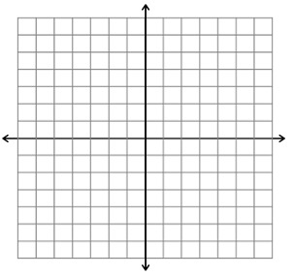 | 4.) Graph the equation. Label the vertex and axis of symmetry. Show your table of values.  x y  Y = (x - 2)² - 4
5.) Use the graph and the given equation to find a quadratic equation in vertex form.  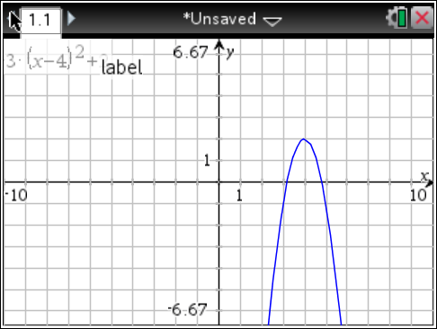  a = -3 | 6.) Use the graph and the given equation to find a quadratic equation in vertex form.  a = 4  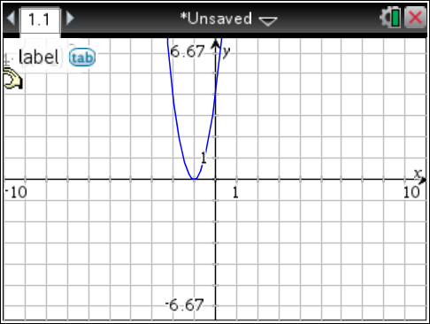
7.) Identify the zero(s) of the quadratic function.  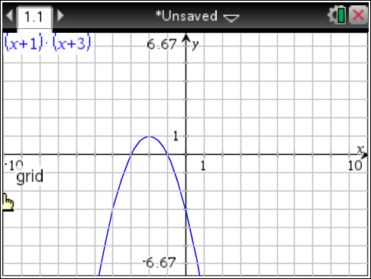 | 8.) Identify and label the zero(s) of the quadratic function.  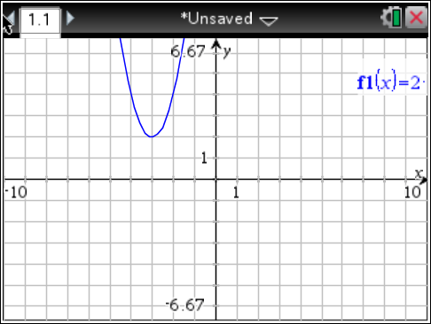
9.) Write the equation for the quadratic function in vertex form. (Hint: Don’t forget about “a”!)  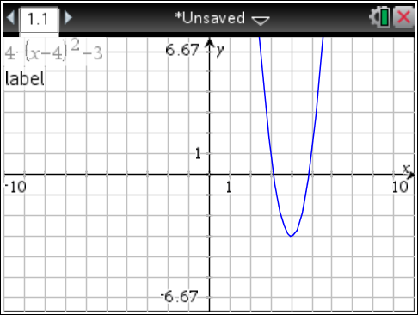 | 10.) Use your calculator to find the values for the following quadratic function. Then sketch the parabola.  f(x) = $\frac{2}{3}$(x - 1)² - 1  Vertex: _____  Axis of Symmetry: _____  Zeros: _____  y-int.: _____

