1.) Write a quadratic equation in vertex form if a = -8, h = 3 and k = 4. | 2.) Identify the vertex of the quadratic function: Y = -1(x + 3)²  What does the (-1) in the equation represent
3.) Graph the equation. Label the vertex and axis of symmetry. Show your table of values.  x y  Y = -(x + 2)² + 4  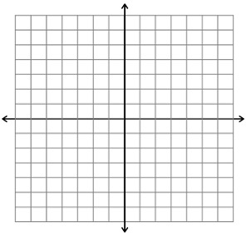 | 4.) Graph the equation. Label the vertex and axis of symmetry. Show your table of values.  Y = 2(x - 1)² - 5  x y
5.) Use the graph and the given equation to find a quadratic equation in vertex form.  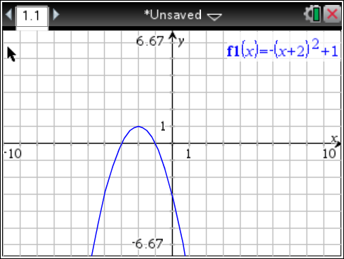  a = -1 | 6.) Use the graph and the given equation to find a quadratic equation in vertex form.  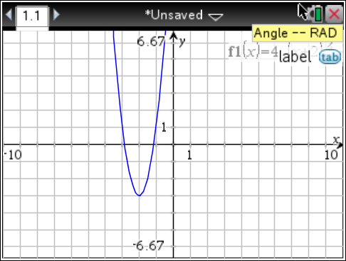  a = 4
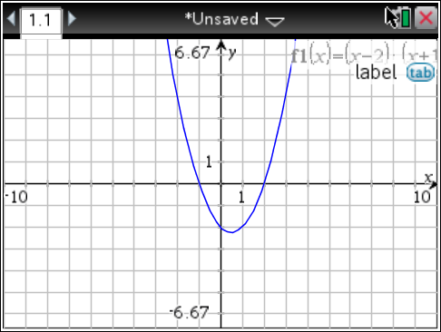  7.) Identify the zero(s) of the quadratic function. | 8.) Identify and label the zero(s) of the quadratic function.  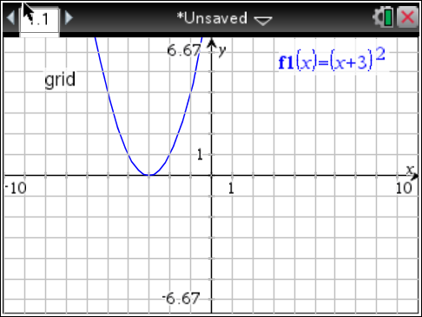
9.) Write the equation for the quadratic function in vertex form. (Hint: Don’t forget about “a”!)  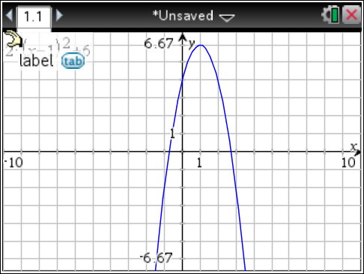 | 10.) Use your calculator to find the values for the following quadratic function. Then sketch the parabola.  f(x) = $-\frac{1}{3}$(x - 2)² + 4  Vertex: _____  Axis of Symmetry: _____  Zeros: _____  y-int.: _____

