1.) Write a quadratic equation in vertex form if a = -4, h = 5 and k = 2. | 2.) Identify the vertex of the quadratic function: Y = 4(x - 2)² - 5  What does the (4) in the equation represent
3.) Graph the equation. Label the vertex and axis of symmetry. Show your table of values.  x y  Y = 2(x - 1)² - 3  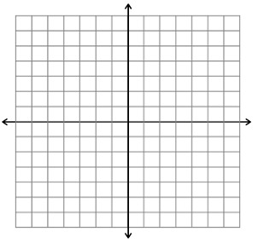 | 4.) Graph the equation. Label the vertex and axis of symmetry. Show your table of values.  Y = -2(x - 1)² + 5  x y
5.) Use the graph and the given equation to find a quadratic equation in vertex form.  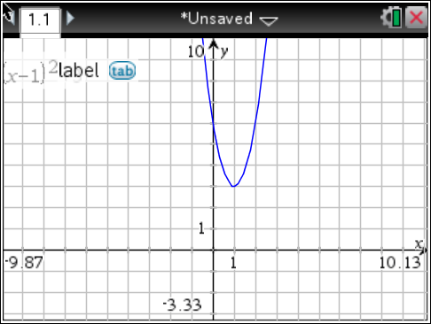  a = 3 | 6.) Use the graph and the given equation to find a quadratic equation in vertex form.  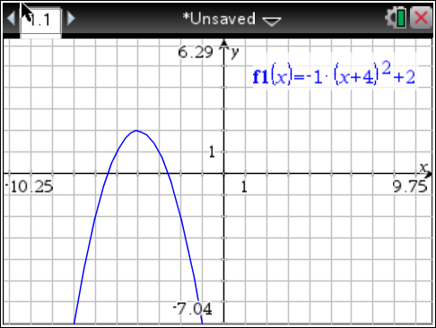  a = -1
7.) Identify the zero(s) of the quadratic function.  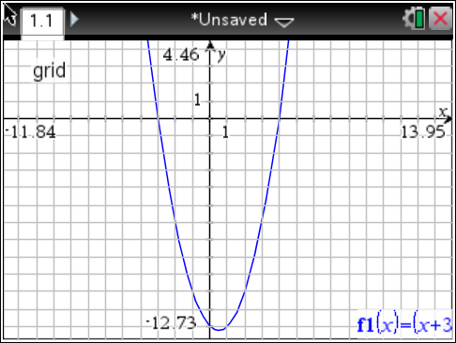 | 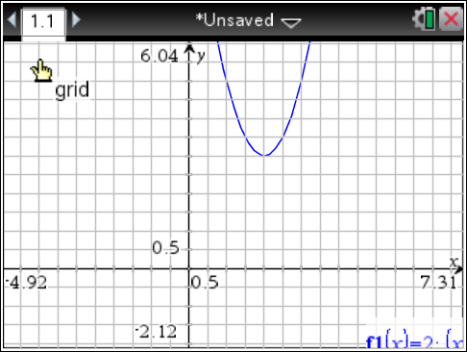  8.) Identify and label the zero(s) of the quadratic function.
9.) Write the equation for the quadratic function in vertex form. (Hint: Don’t forget about “a”!)  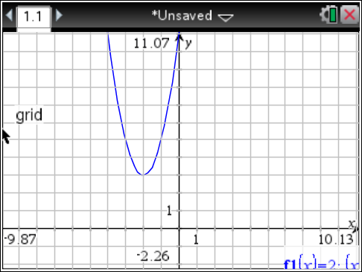 | 10.) Use your calculator to find the values for the following quadratic function. Then sketch the parabola.  f(x) = $\frac{1}{2}$(x - 3)² - 3  Vertex: _____  Axis of Symmetry: _____  Zeros: _____  y-int.: _____

