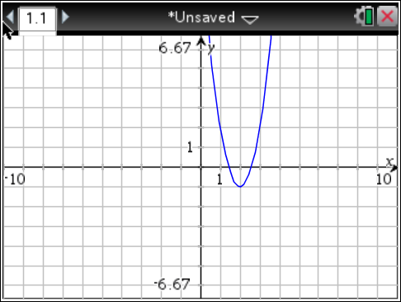**Notes - Writing Vertex Form Equations and finding “a”**.

Use the graph.

**Step 1.)** Identify the __________ ( , )

**Step 2.)** Write the __________ _______ equation, WITH the variable “a”.

_________________________

**Step 3.)** Find another ________ on the __________ ( , )

**Step 4.)** Plug ___ and ___ into your equations from **Step 2** and _______ for ___. _________________________

**Step 5.)** Write your final equation with the ___-value included in the equation. _________________________

**Try this: Write the equation for the parabola below. Follow steps 1-5!**

