Notes 3 - Section 10-1 “Exploring Quadratic Graphs” Name ________________________________

Examples 2 and 3

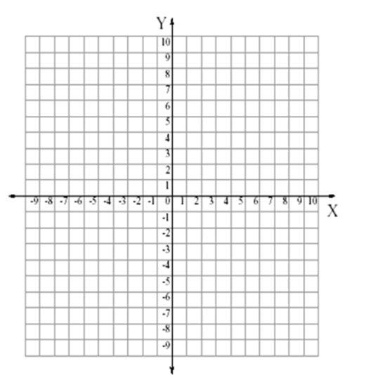

Example 4

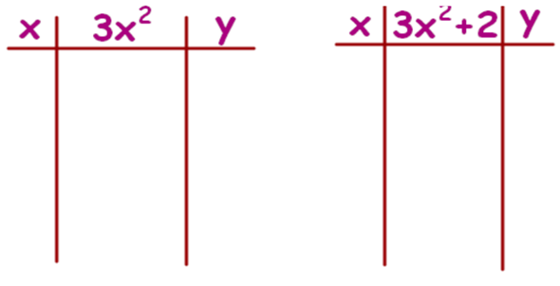 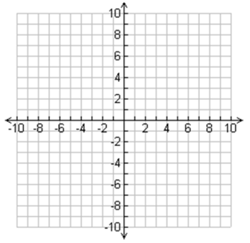

What does **c** tell you about each graph?

Check Understanding. - Graph the function y = 2x² + 4

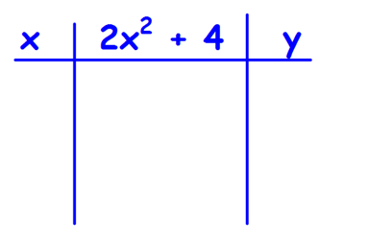 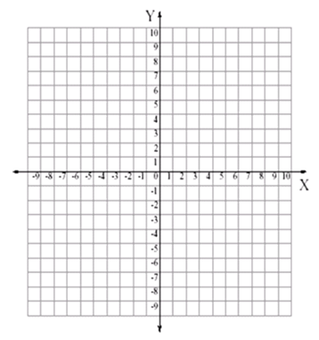

Example 5

