10-2 Quadratic Functions Name ________________________
Algebra 1 Date _______________ Hour _____

Find the value of x at the vertex of each equation. Write the equation for the line of symmetry.

Use –b to find x at the vertex.
2a

1) y = x² + 6x + 7 2) y = ½ x² - 4x – 2 3) y = -2x² - 4x - 4 4) y = -x² + 2x - 6

A.O.S. __________ A.O.S. __________ A.O.S. __________ A.O.S. __________

Find the value of y at the vertex for each of the equations above. (Substitute the value that you found for x into the
equation and solve for y.) Write the coordinates of the vertex for each equation.

1) y = x² + 6x + 7 2) y = ½ x² - 4x – 2 3) y = -2x² - 4x - 4 4) y = -x² + 2x - 6

Vertex ______ Vertex ______ Vertex ______ Vertex ______
Graph each of equations from the other side of the worksheet. Label the vertex and the axis of symmetry on each
graph.

1) 2)

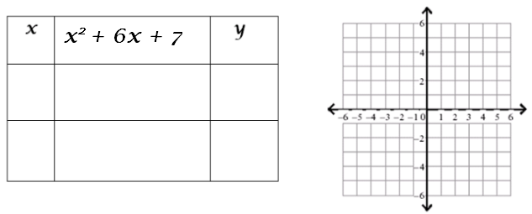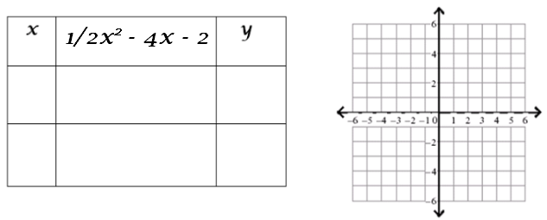

3) 4)
