10-1 Exploring Quadratic Graphs Name ___________________
Algebra 1 Date ___________ Hour ____

Identify the vertex of each graph. Tell whether it is a minimum or a maximum.

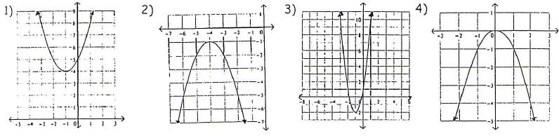
vertex: ______ vertex: _____ vertex: _____ vertex: ______
Minimum or Maximum? Minimum or Maximum? Minimum or Maximum? Minimum or Maximum?

5) Use the graphing calculator to graph each of the equations below.
Then sketch each graph on graph paper. Label each vertex.
a) y = x² b) y = 2x² c) y = -2x² d) y = ½ x²
6) What is the shape of each graph in #5?
7) Which graph is widest? Which graph is narrowest?
8) Fill in the table below for the first four equations.
Equation | Does the curve open  up or down? | Vertex | Is the vertex a maximum or a minimum?
y = x²
y = 2x²
y = -2x²
y = ½ x²
y = x² + 3
y = -x² - 3
9) Use the graphing calculator to graph each of the equations below. Then
sketch each graph on graph paper.
a) y = x² + 3 b) y = -x² - 3

10) Fill in the table above for the equations from #9. What happened to the
vertex when a constant was added to or subtracted from the x² term?

