**Algebra 1 Name ____________________**

**Date ____________ Hour ___**

**Solving Systems of Equations by Graphing - Word Problems**

Directions: Answer all questions. Show all work!!!

**POPULATION**For exercises 1-3, use the following information. The U.S. Census Bureau divides the country into four sections. They are the Northeast, the Midwest, the South, and the West. The populations and rates of growth for the Midwest and the West are shown in the table.

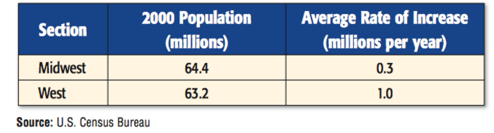

1. Write an equation to represent the **population of the Midwest** for the years since 2000.

2. Write an equation to represent the **population of the West** for the years since 2000.

3. **Graph** the population equations. Assume the rate of growth of each of these areas remained the

same. Estimate the solution and interpret what it means.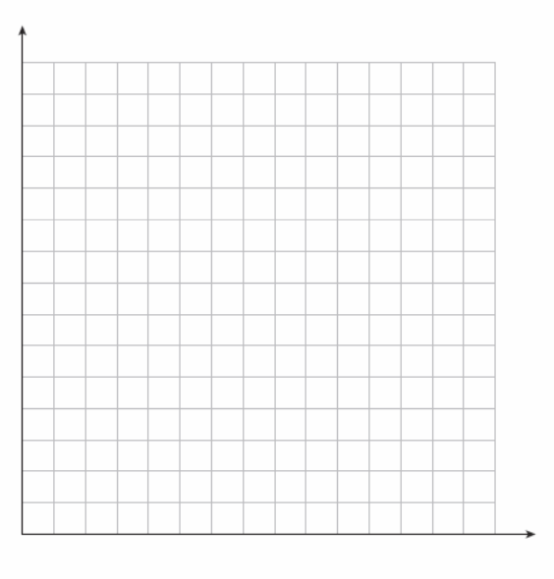

**SPORTS**For exercises 4-6, use the following information. The number of girls participating in high school soccer and track and field has steadily increased during the past few years.

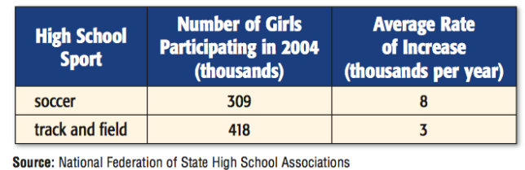

4. Write an equation to represent the **number of girls participating in soccer** since 2004.

5. Write an equation to represent the **number of girls participating in track and field** for the since

2004.

**6. Graph** the equations. Assume the rate of growth of each of these areas remained the same. Estimate

the solution and interpret what it means.



PHOTOGRAPHYFor exercises 7-9, use the following information. Since 2000 the number of film cameras sold has decreased at an average rate of 2.5 million per year. At the same time, the number of digital cameras sold has increased an an average rate of 2.6 million per year.

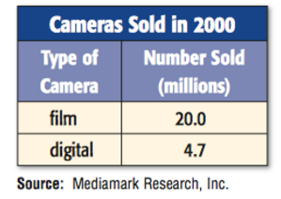

7. Write an equation to represent the **number of film cameras** sold in 2000.

8. Write an equation to represent the **number of digital cameras** sold in 2000.

9. **Graph** the equations. Assume the rate of growth of each of these areas remained the same. Estimate

the solution and interpret what it means.

